**Project Edulead**

**USER MANUAL**

**Payroll**



**Sustainable Outreach &**

**Universal Leadership Limited**

**00. General Procedures :-**

1. **General Procedures for a Save Screen :-** 
   1. **Create of New document :-**
2. Login in to the system
3. Go the required workspace

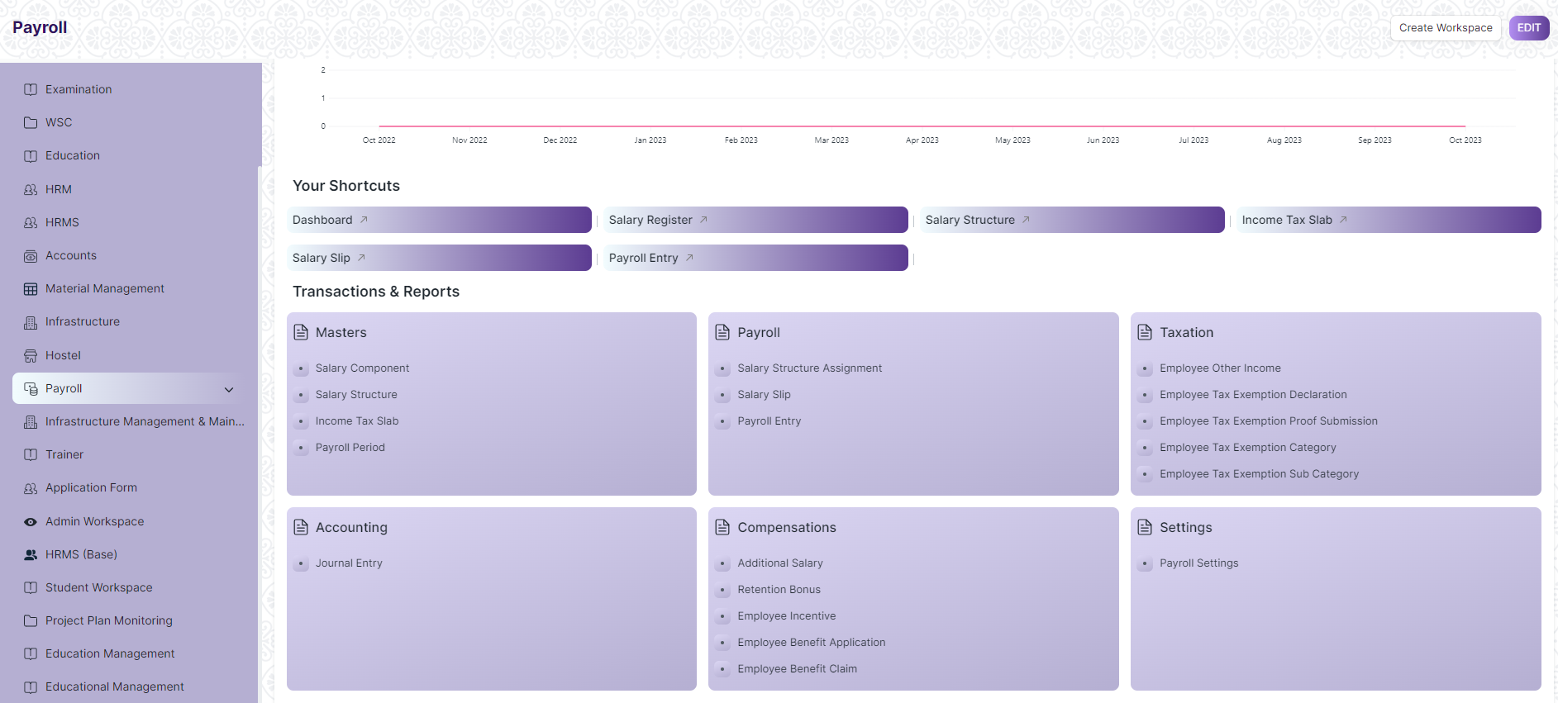

* Go to the required screen.
* Click on the ***“+ Add Screen Name”*** button in the right corner of the screen.

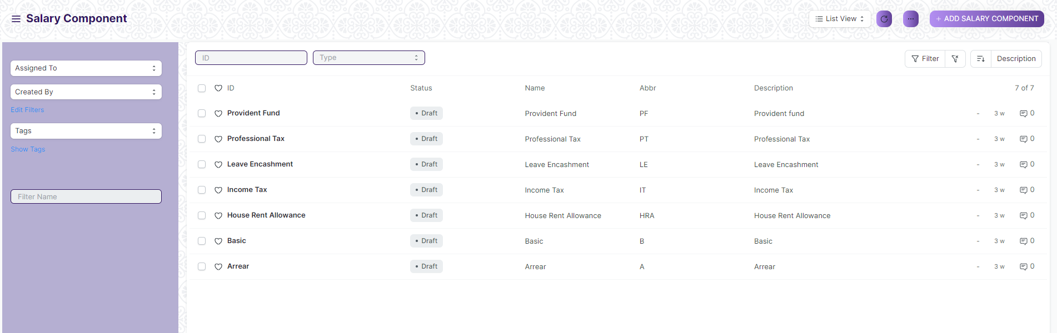

(Example : For addition in the new Employment Type , click ***+ Add Salary Component*** button).

* Enter the required data.
* Click on ***Save*** & ***Submit***
* After saving , the record will be visible in the List View of the screen



(Example : List view of saved Employment Types)

* 1. **View a Saved Document :-**
* Log in to the system.
* Go to the required workspace
* Go to the required screen.
* Click on the required document from the list view of the screen.



(Example : View of ***Income Tax*** Document of Employment Type Screen)

View the clicked document.

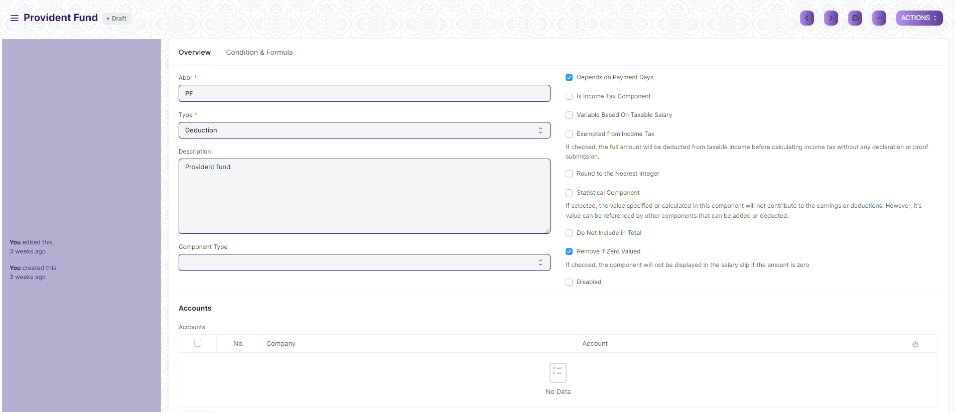

(Example : View of the ***Provident Fund*** Screen)

* 1. **Delete a Saved Document :-**
* Log in to the system
* Go to the required workspace
* Go to the required screen.
* Click on the required document from the list view of the screen.
* Click on the 3 dots in the right corner of the screen.
* Click on ***Delete*.**

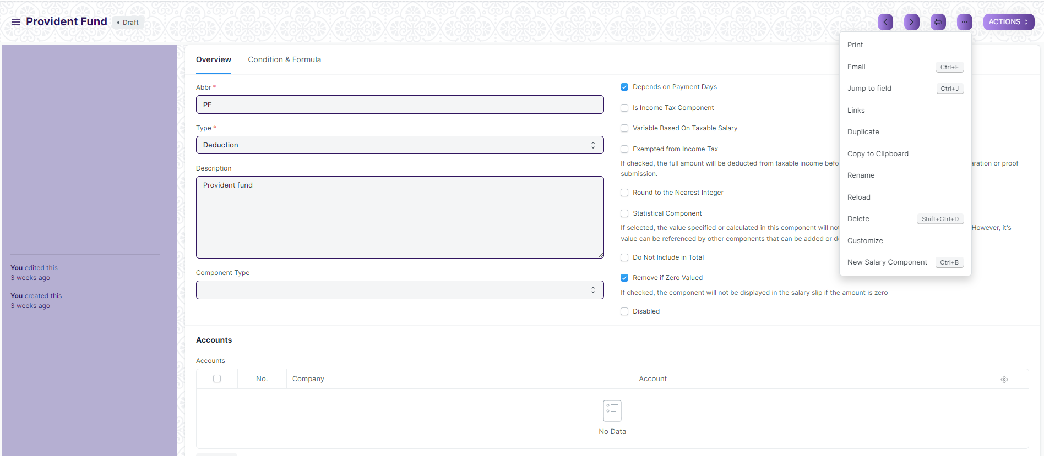

(Example : Deletion of ***Provident Fund*** document of Employment Type)

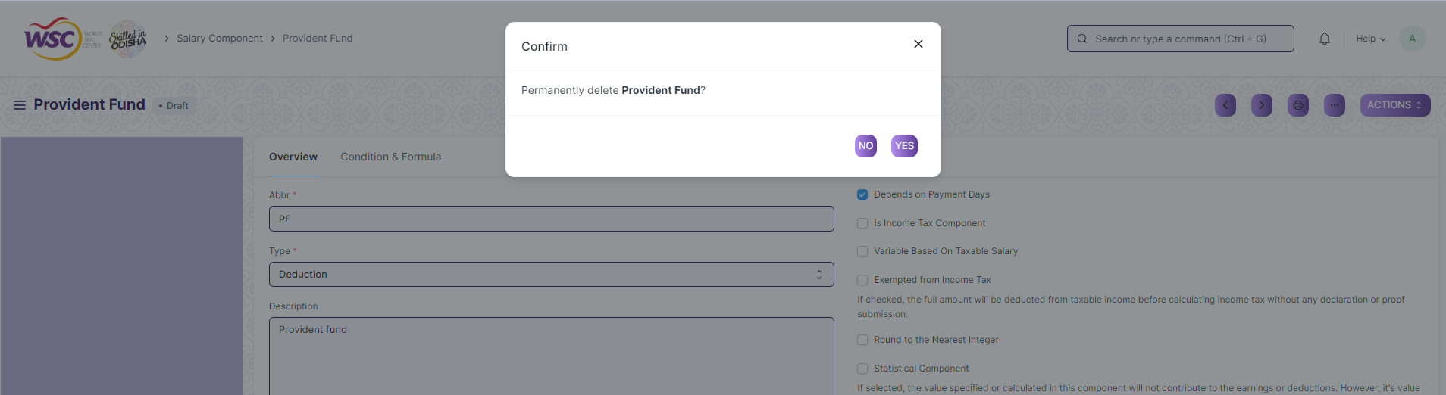

(Example : Clicking Yes to Delete permanently the document)

* 1. **Rename a Saved Document :-**
* Login to the screen.
* Go to the required workspace
* Go to the required screen.
* Click on the required document from the list view of the screen.
* Click on the 3 dots in the right corner of the screen.
* Click on ***Rename***



* Click on *“****Rename”*** button to rename the document.

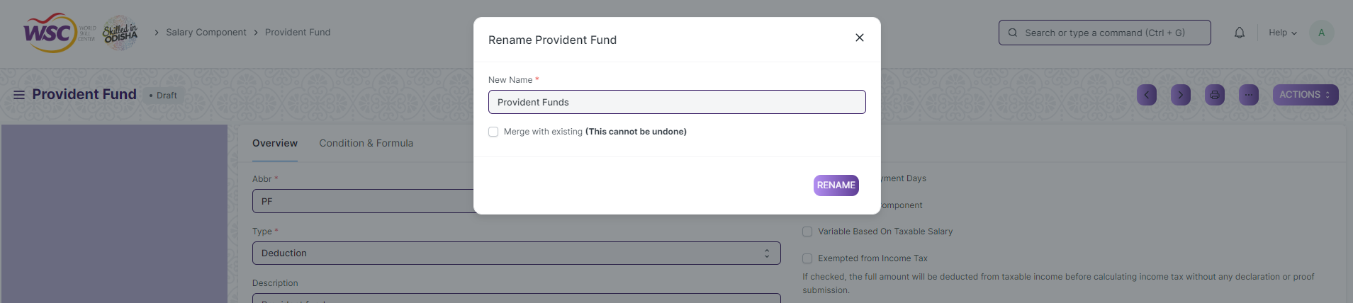

* 1. **Print a Saved Document type :-**
* Login to the system
* Go to the required workspace
* Go to the required screen.
* Click on a saved document in the screen.
* Click on the print button present in the right corner of the screen.

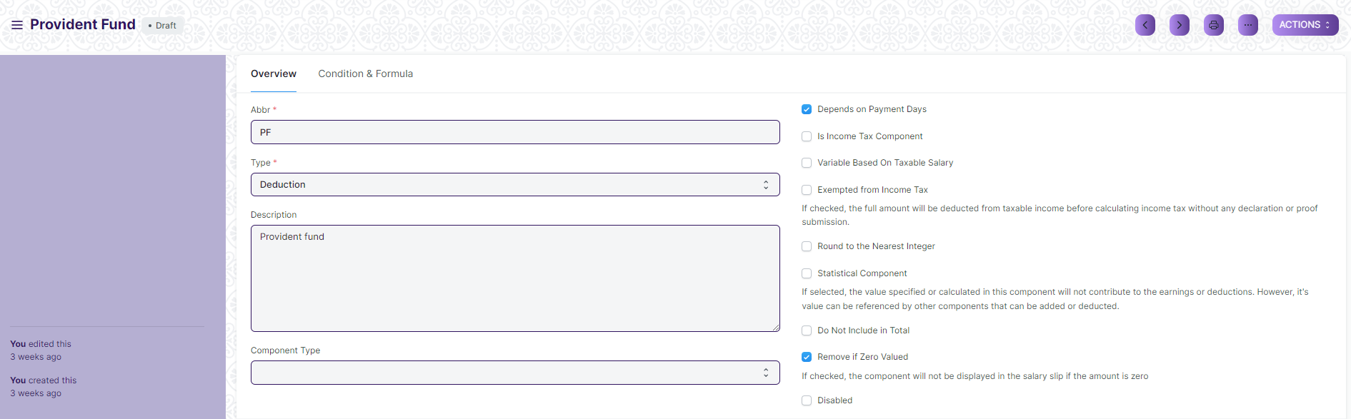

* A new screen will open.
* Click on the print button to Print the document.

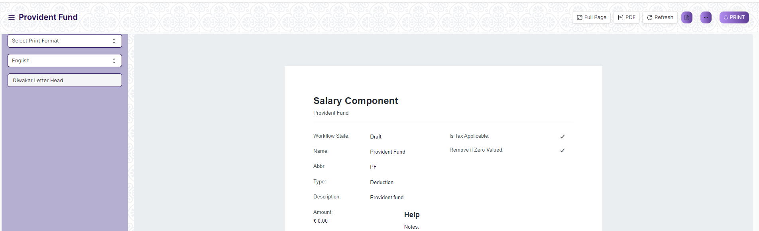

* To download the employment type as PDF , click on the PDF button .



* 1. **View the saved document in different format :-**
* Login to the system
* Go to the required workspace
* Go to the required screen.
* Click on the List View Button in the screen.

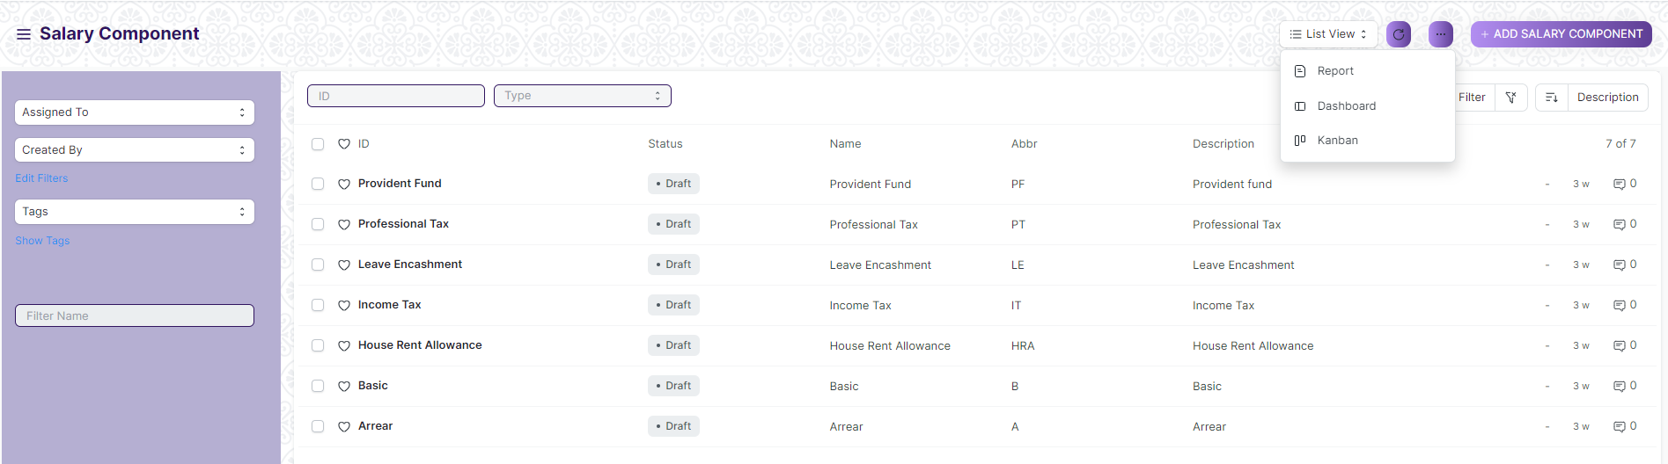

* Select the appropriate view type that you want.
  1. **View the saved documents by applying filters :-**
* Login to the screen.
* Go to the required workspace.
* Go to the required screen.
* Click on the ***Filter***.

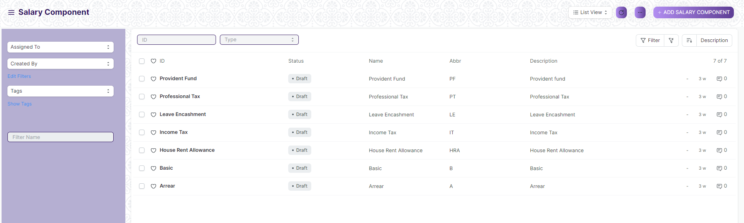

* Select the field of the document based on which you wish to filter the records. All the fields in a form will be selectable in this list.

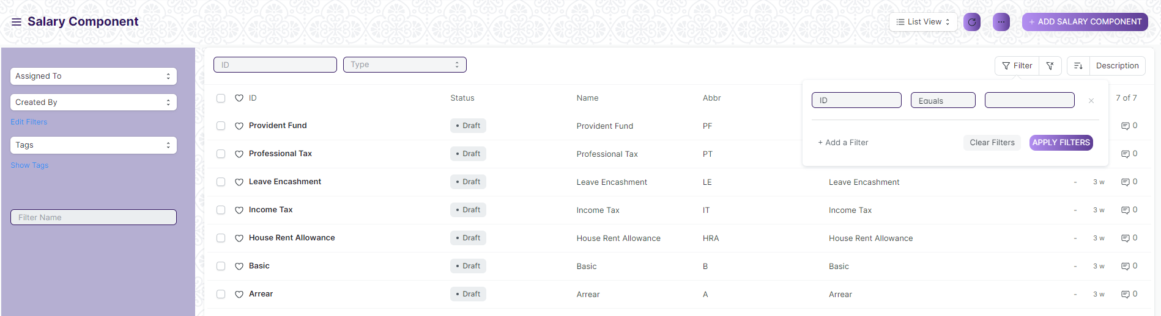

**Based On :** For the field, you will be required to put a value of the field. In the 'based on' field.

**Criteria :** You can define criteria based on which the system will search the document.The different conditions on which the filters are based are: Equals, Not Equal, Like, Not Like, In, Not In, =,>,< etc.

**Value :** Here, you will be required to enter the value for which you are running the document search.

**>>> Some Examples of Viewing the documents in the list view after applying filters :-**

Filter on Employee Screen where, the full name starts with ‘A’

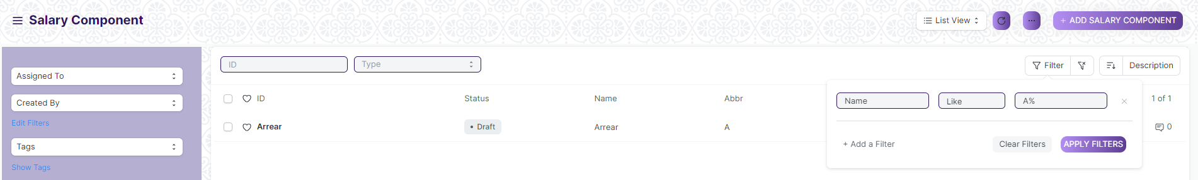

**>>> Example of Multiple filter :-**

Applying filter in the employee screen , where date of joining is greater than some date and gender is equal to Male.

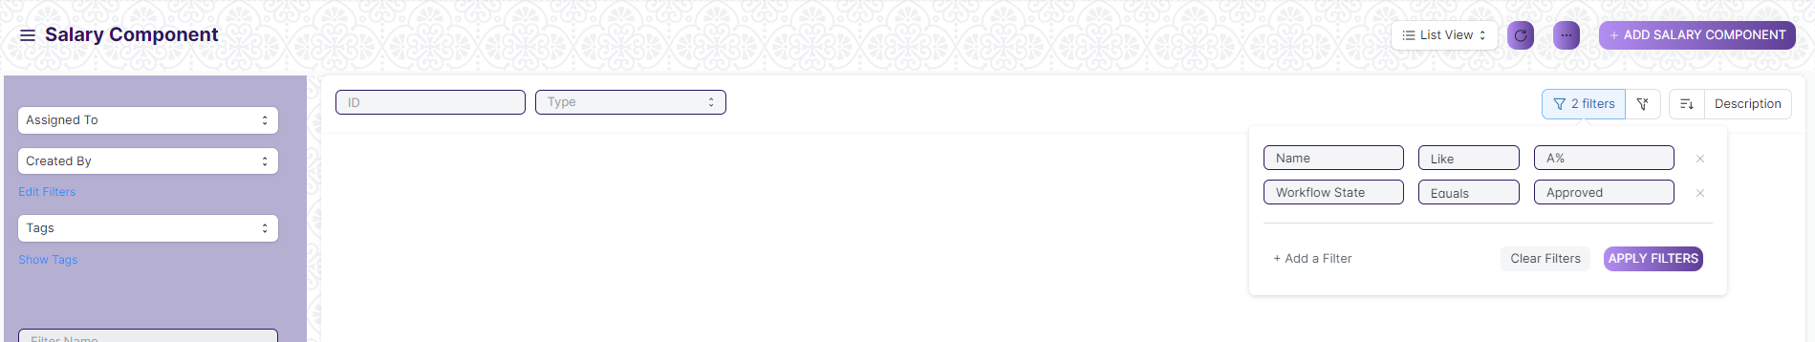

**>>> Default Filters :-**

There are some filters present out of the box for the views which can be used for filtering the search results.

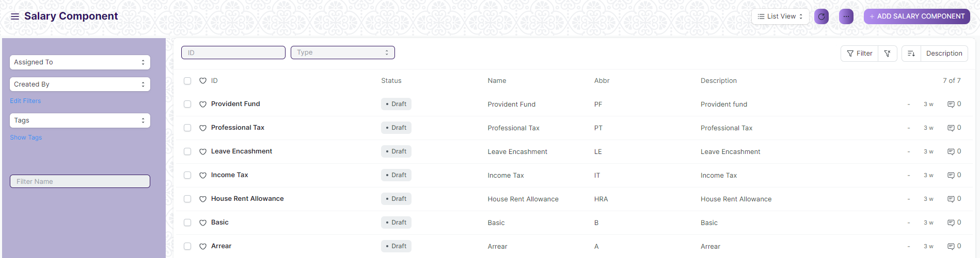

**2. General Procedure for a Submittable Screen :-**

**2.1. Create of New document**

* Login in to the system
* Go the required workspace
* Go to the required screen.
* Click on the ***“+Add Screen Name”*** button in the right corner of the screen.



(Example : For addition in the new Employment Type , click +Add Salary Component button).

* Enter the required information in the document.
* Once you are finished entering the information , click the ***“Save”*** button.
* After saving it , a submit button will appear.

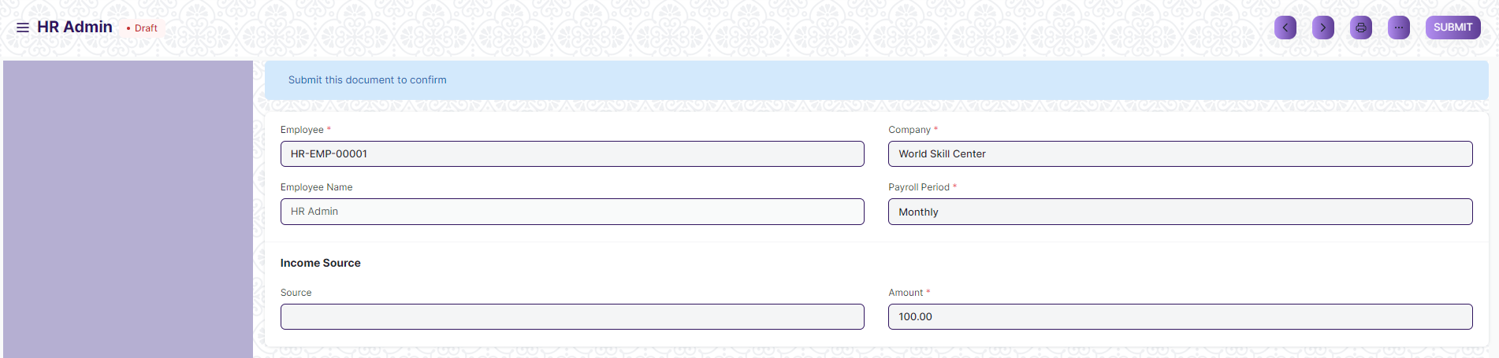

* Click on the **“Submit”** button.
* A confirmation dialog box will appear . Click the Yes button to submit the document.

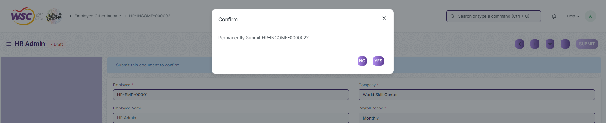

* After submitting , the record will be visible in the List View of the screen.

**Note :** The process of creation can only be carried out by employees who have necessary permission.Kindly refer to the Screen wise permission section in the document.

**2.2. Cancel a Submitted Document :-**

* Log in to the system.
* Go to the required workspace
* Go to the required screen.
* Click on the required document from the list view of the screen.
* Click the ***Cancel*** Button .

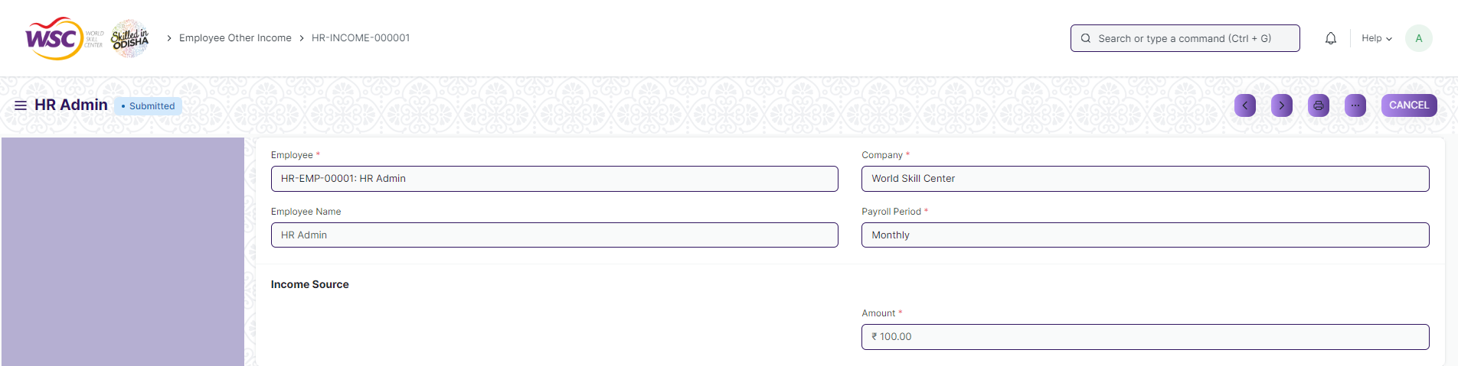

* A confirmation dialog box will appear . Click the Yes button to cancel the document.

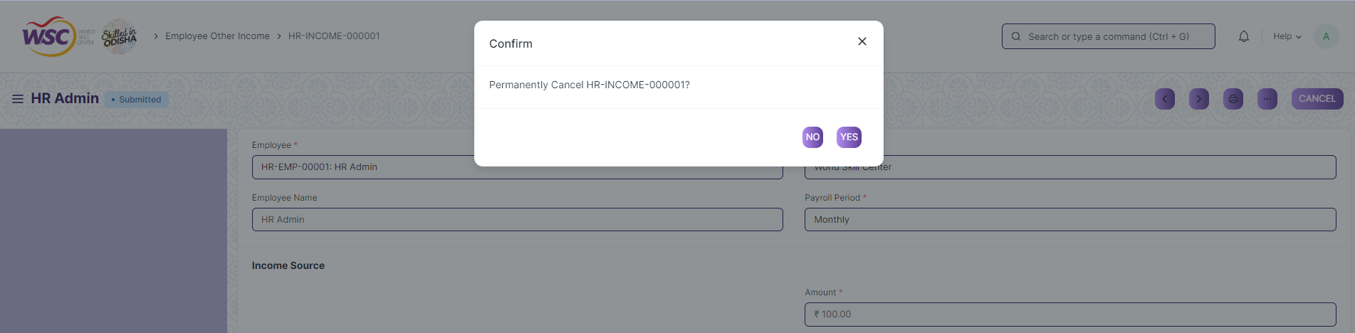

**2.3. Amend a Submittable Document :-**

* Log in to the system.
* Go to the required workspace
* Go to the required screen.
* Click on the required document from the list view of the screen.
* After cancellation of the document , an Amend button will appear on the screen.

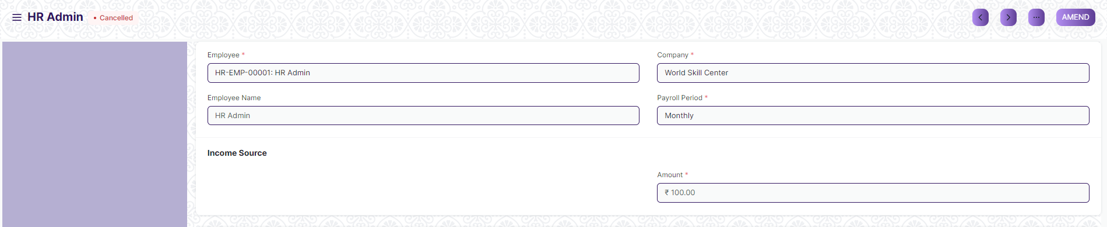

* Click the “***Amend”*** button.
* A new document will be created with the same information as the original document .

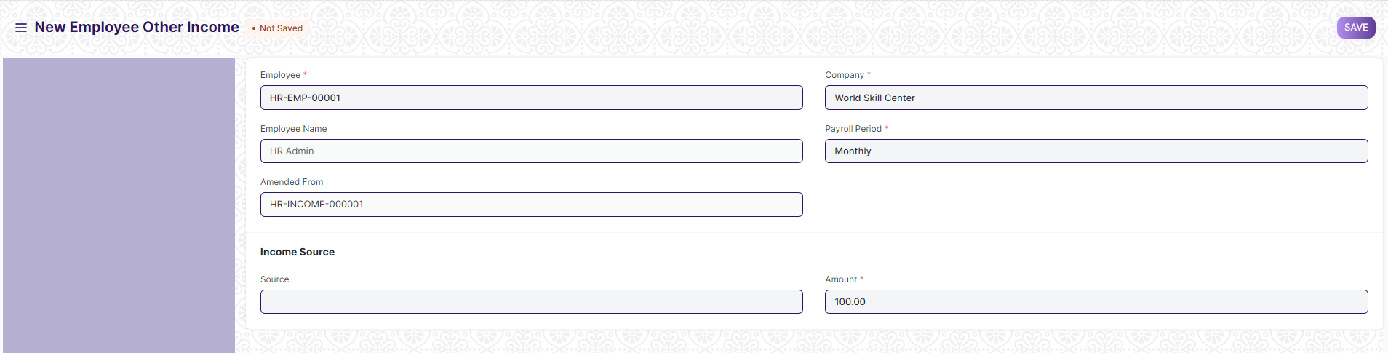

* You can now make changes to the document as needed.

**2.4. Delete a Submittable Document :-**

* Log in to the system.
* Go to the required workspace
* Go to the required screen.
* Click on the required document from the list view of the screen.
* If the document is in draft sate , you can follow the procedure to delete a save document .
* If the document is submitted , then cancel it first , then delete it.

After cancellation of the document , an Amend button will appear on the screen.

**2.5. Action Menu on a document :-**

The three dots menu, located in the right corner of a document in a Screen , offers a range of actions and options to manage and interact with the document.

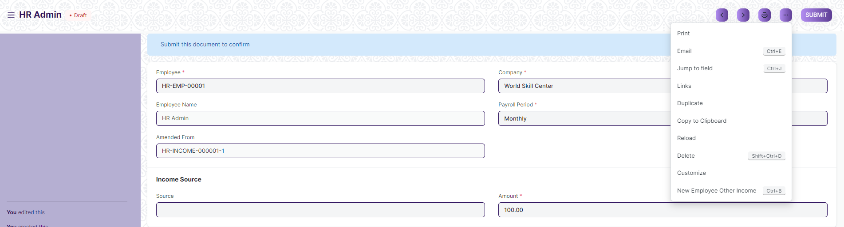

The functionalities available in the three dots menu are given below .

**Print :** Print Enables you to generate a printable version of the document ., which you can save as a PDF or send to a printer.

**Email :** Click on Email allows you to send the document as an attachment via email to specified recipients.

**Duplicate :** Create a new document with the same information as the current one.

**Delete :** Permanently remove the document.

**Cancel :** Cancel the submitted document.

**Submit :** Submit the document . If the document is submittable.

**Links :** This Option displays a list of document that are linked to the current document. You can navigate these linked documents from here.

**Jump to field :** You can directly go the required field by clicking this option and giving appropriate field name.

**Copy to Clipboard :** By clicking this option you can copy the content of the document .

**Rename :** By clicking the Rename option you can Rename the document.

1. **Salary Component :-**

Salaries are paid by organizations to their employees in exchange for the services rendered by them. The different components that make up the Salary Structure are called as Salary Components. Salary paid to the employees comprises of several different components, such as basic salary, allowances, arrears, etc.

**>>> To access Salary Component, go to :-**

***Home > Human Resources > Payroll > Salary Component***

**>>> How to create a salary component :-**

1. Go to Salary Component list, click on ***+ Add Salary Component***

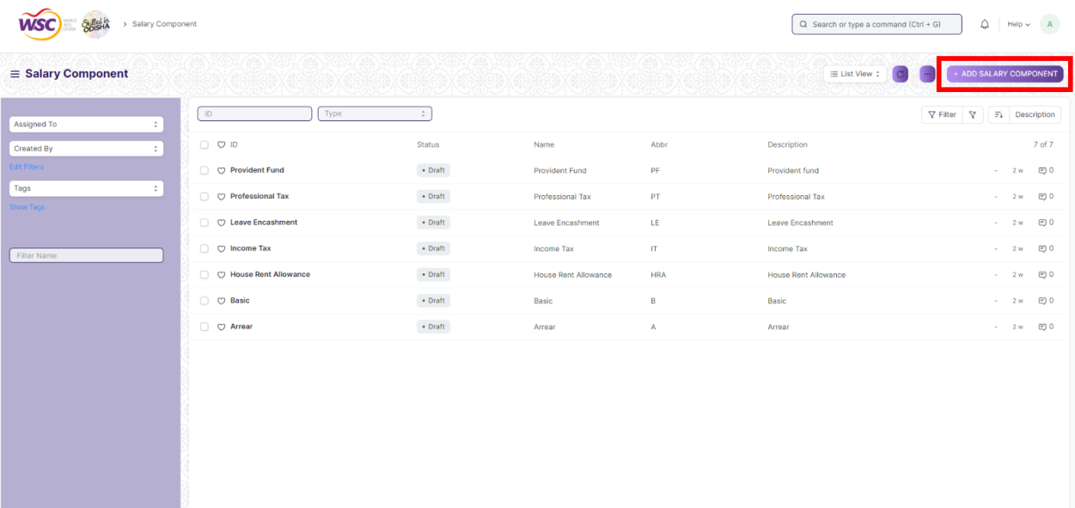

**>> In the overview :-**

2. Enter ***Name*** and ***Abbr.*** (Abbreviation)

3. Choose ***Type*** (Earning or Deduction)

4. Enter ***Description*** (optional)

5. In ***Accounts*** section Click on ***Add Row*** and Enter ***Company*** and ***Account***

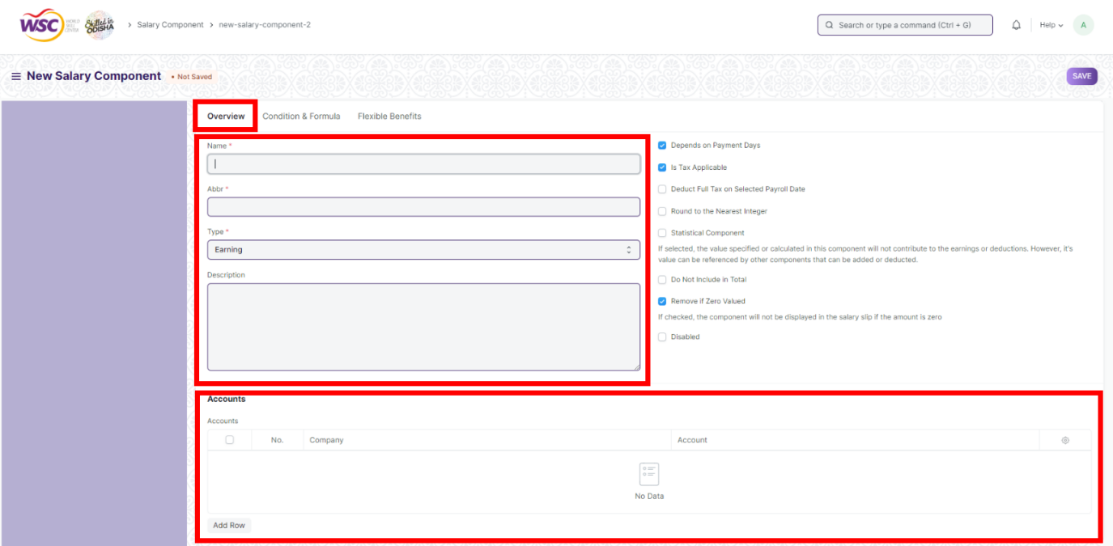

**>> In the Condition & Formula :-**

6. Enter ***Condition*** and ***Amount***

7***.*** Check the checkbox ***Amount based on formula***

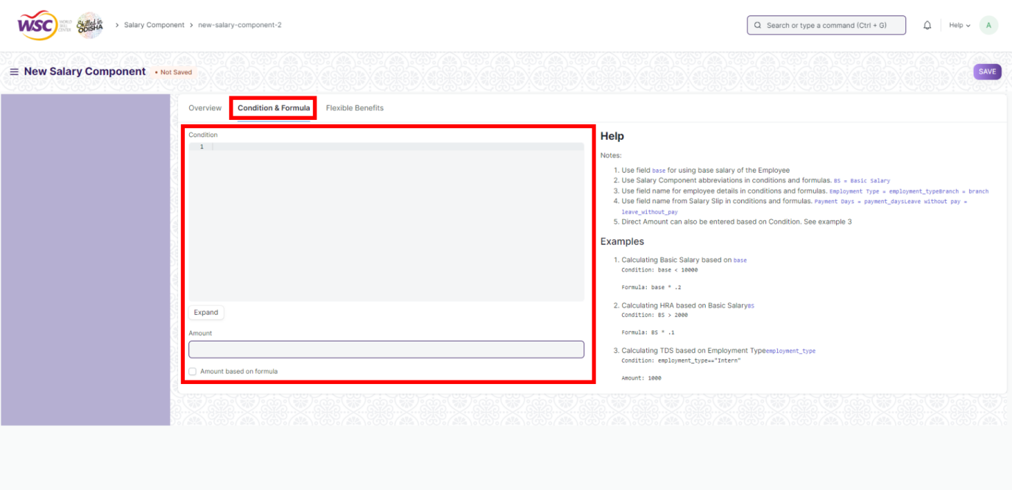

**>> In the Flexible Benefit :-**

8**.** Check the checkbox ***Is Flexible Benefit*** if it is a flexible benefit.

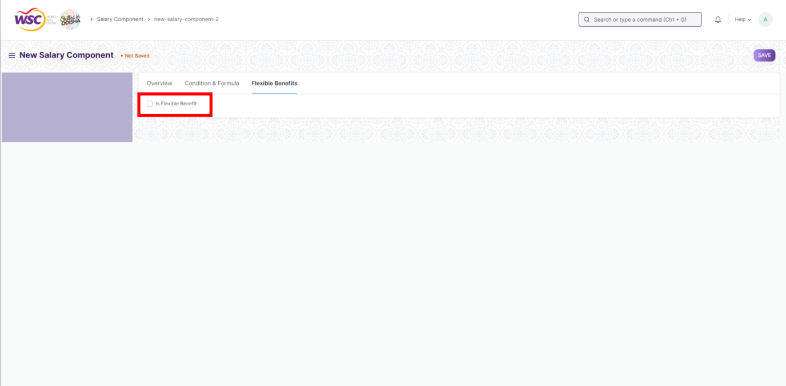

1. Save & Submit

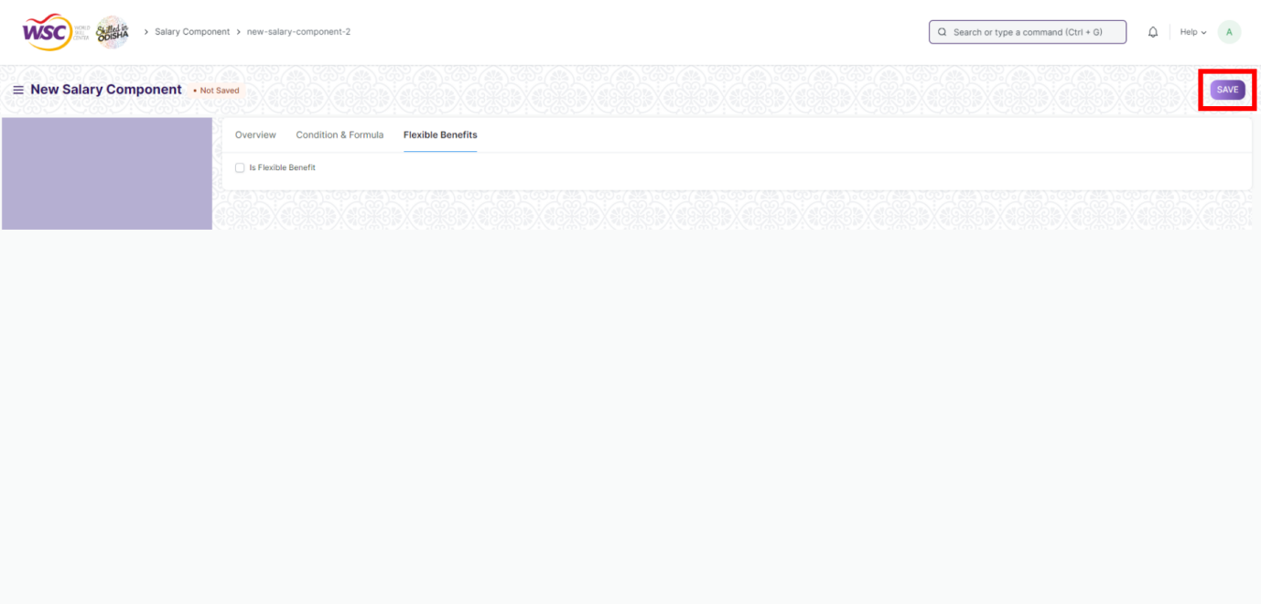

**>>> Additional Properties:-**

Some of the additional attributes of the Salary Component that can be enabled using check-boxes are as follows :-

**Is Payable :-** Select this if the Salary Component is payable.

**Depends on Payment Days :-** If this checkbox is enabled then the Salary Component will be calculated based on the number of working days.

**Is Tax Applicable :-** This checkbox is applicable for Earning Components. Selecting this checkbox allows tax to be applied on this Salary Component.

**Deduct Full Tax on Selected Payroll Date :-** If checked and the component is used in Additional Salary, the tax amount applicable on the additional amount will be deducted on the specific payroll month. If not checked, the tax will be distributed over the remaining months of the payroll period. For example, if a bonus is given in a particular month using Additional Salary, then you can deduct full tax amount in the same month only.

**Round to the Nearest Integer :-** Selecting this checkbox allows you to round the amount of this Salary Component to the nearest integer.

**Statistical Component :-** If selected, the value specified or calculated in this component will not contribute to the earnings or deductions. However, it's value can be referenced by other components that can be added or deducted. If you set a Salary Component as a Statistical component, then you do not have to set the Default Account for the same. Also, you would not be able to set this component as a Flexible Benefit.

**Do Not Include in Total :-** Selecting this checkbox ensures that the Salary Component is not included in the Total Salary. It is used to define the component which is part of the CTC but not payable (e.g. Usage of Company Cars).

**Variable Based On Taxable Salary :-** The component is calculated automatically on taxable income based on applicable Income Tax Slab (e.g. TDS or Income Tax).

**Exempted from Income Tax :-** If checked, the full amount will be deducted from taxable income before calculating income tax without any [declaration](https://frappehr.com/docs/v14/user/manual/en/human-resources/employee-tax-exemption-declaration) or [proof submission](https://frappehr.com/docs/v14/user/manual/en/human-resources/employee-tax-exemption-proof-submission). For example, Professional Tax in India is deducted from taxable income before calculating income tax.

**Disabled :-** This checkbox can be selected to disable this Salary Component. A disabled Salary Component cannot be used in the Salary Structure.

1. **Salary Structure :-**

Salary Structure is the details of the salary being offered to an Employee, in terms of the breakup of the different components constituting the compensation. Any changes to the Salary Structure i.e. among the components can have a major impact on what the Employee does, such as the kind of tax exemptions claimed.

**>>> To access Salary Structure, go to :-**

***Home > Human Resources > Payroll > Salary Structure***

**>>> Prerequisites :-**

Before you create a Salary Structure, it is advisable you to create following :-

1. ***Salary Component.***

**>>> How to create a Salary Structure :-**

1. Go to the Salary Structure list, click on ***+ Add Salary Structure***

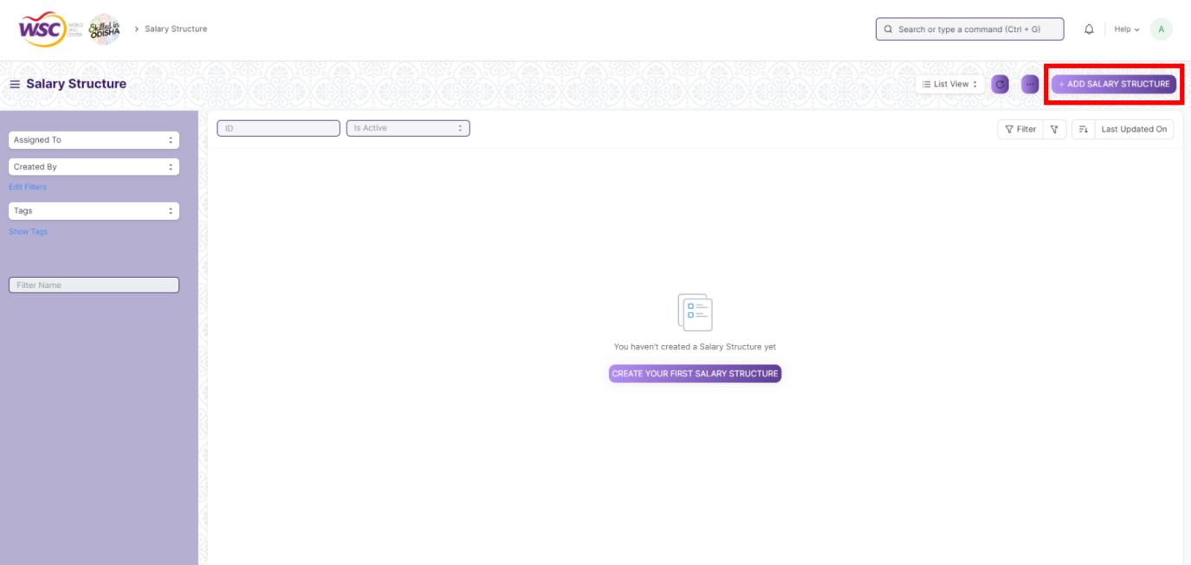

**>> In detail :-**

2. Enter ***Name***, ***Leave Encashment******Amount Per Day (INR)*** (Optional), ***Max Benefits (INR)*** (Optional)

3. Select ***Letter Head*** (Optional) & ***Payment Frequency***

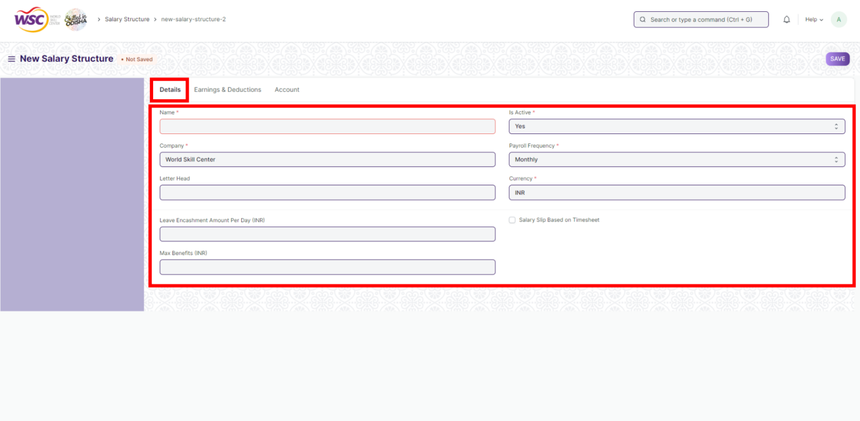

1. Check ***Salary Slip Based on Time Sheet*** (Optional) (If selected Payment Frequency option will be hidden. Now, Select ***Salary Component*** & ***Hour Rate (INR)***

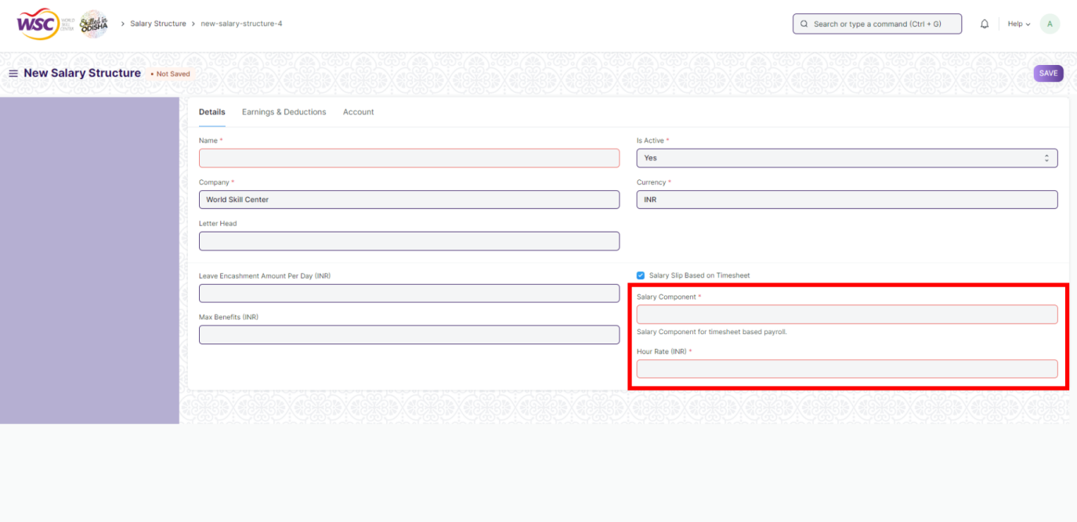

**>> In Earning and Deduction :-**

4. Select ***Components in Earnings & Deductions***

5. Set ***Amount***

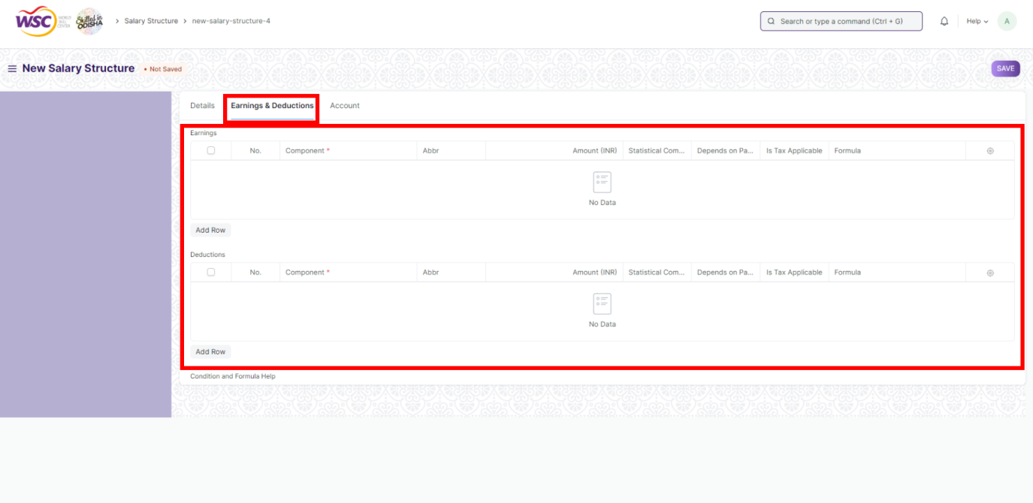

**>> In Account** :-

6. Select ***Mode of Payment*** & ***Payment Account***

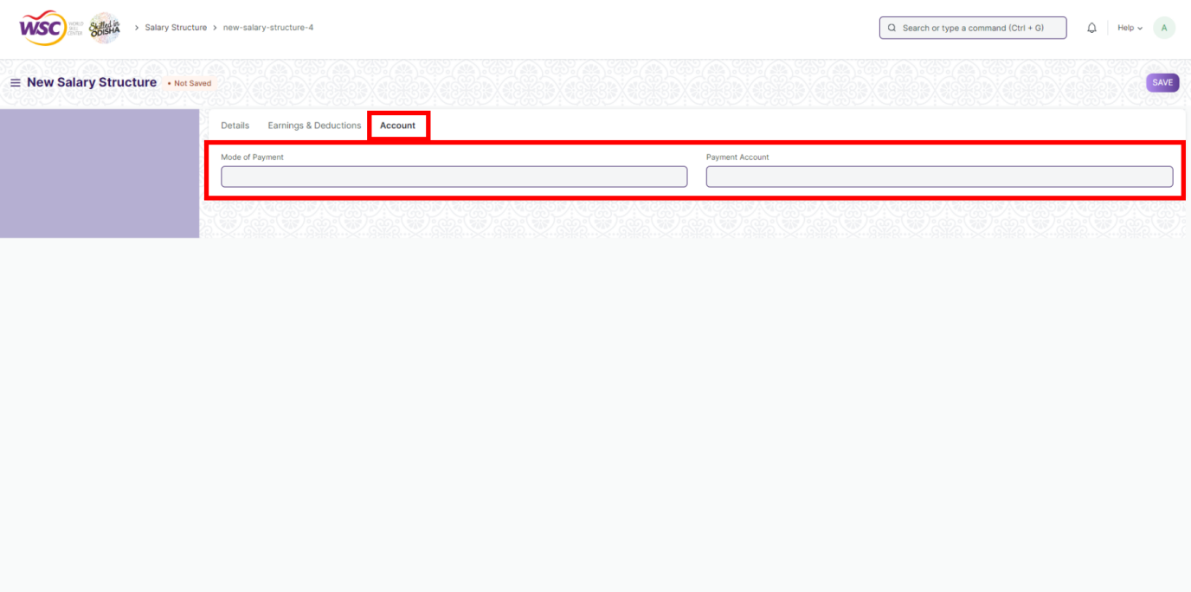

1. ***Save*** & ***Submit***
2. **Income Tax Slab :-**

Income Tax Slab is a document to define income tax rates based on different taxable income slab. Income tax is levied on individual taxpayers based on a slab system where different tax rates have been prescribed for different slabs and such tax rates keep increasing with an increase in the income slab. Multiple Income Tax Slabs can be defined and can be linked them to individual employee's salary structure via Salary Structure Assignment.

**>>> To access Income Tax Slab, go to :-**

***Home > Human Resources > Payroll > Income Tax Slab***

**>>> How to create an Income Tax Slab :-**

1. Go to the ***Income Tax Slab*** list, click on ***+ Add Income Tax Slab***

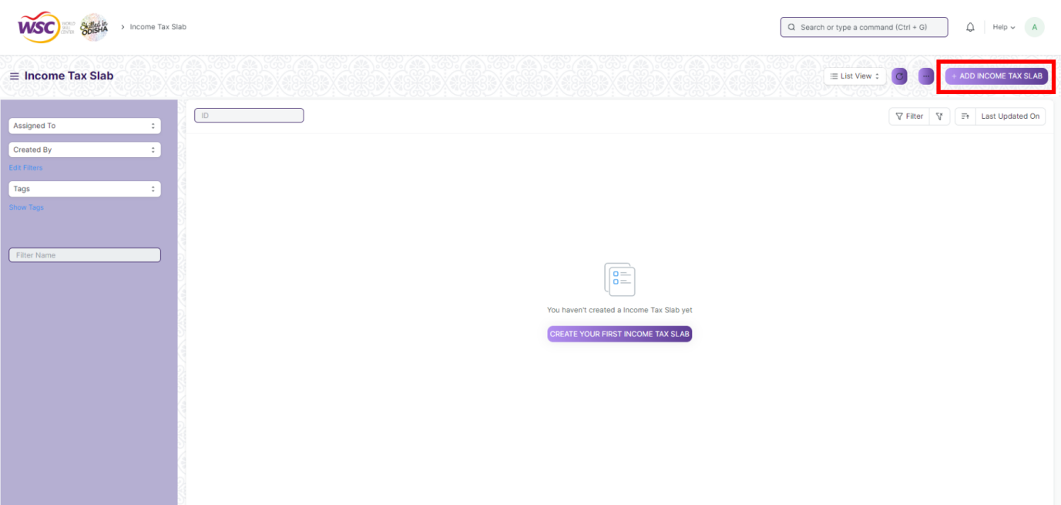

2. Enter ***Name,*** Select ***Effective From*** (Date)

3. Enter ***Standard Tax Exemption Amount*** (Optional)

4. Check ***Allow Tax Exemption*** checkbox (If enabled, Tax Exemption Declaration will be considered for income tax calculation.)

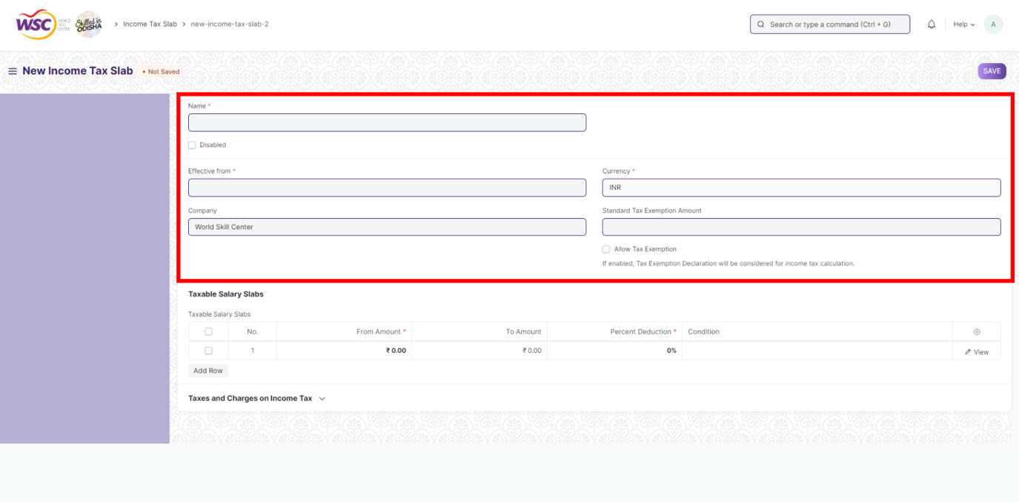

**>> In Tax Salary Slabs :-**

5. Enter ***From Amount***, ***To Amount***, ***Percentage Deduction***

6. Enter ***Condition*** (If Applicable, Optional)

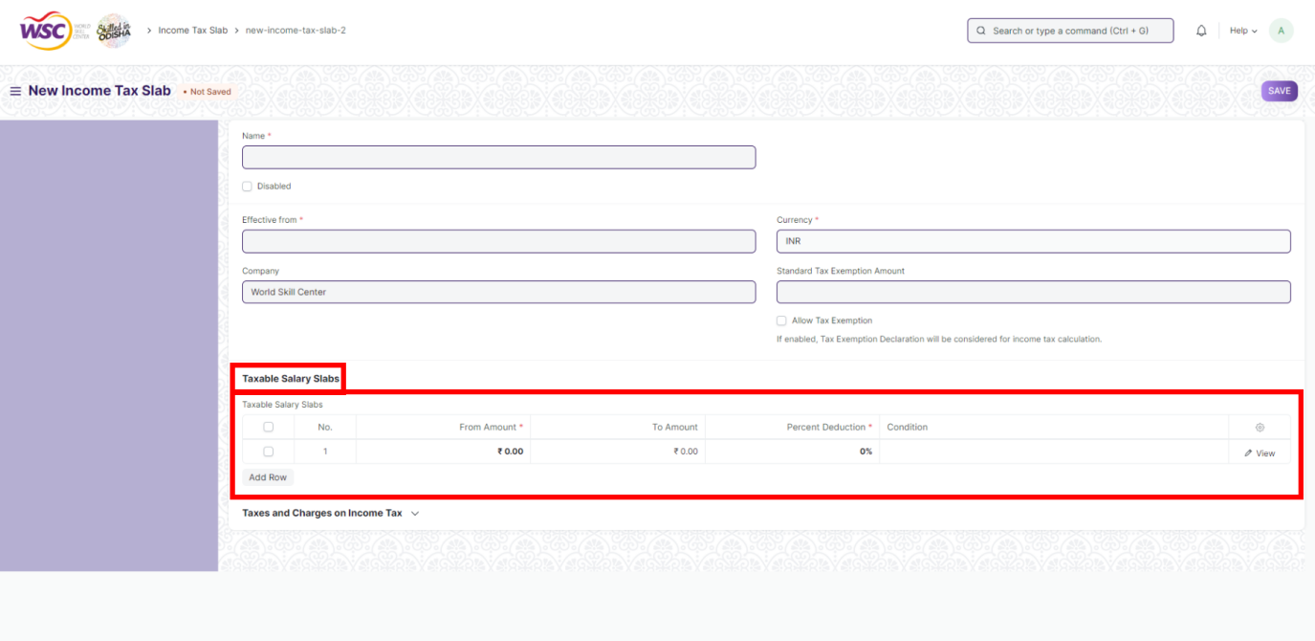

7. Go to ***Taxes & Charges on Income Tax*** Section

8. Enter ***Description***, ***Percentage*** & ***Conditions*** (***Min Taxable Income***, ***Max Taxable Income***)

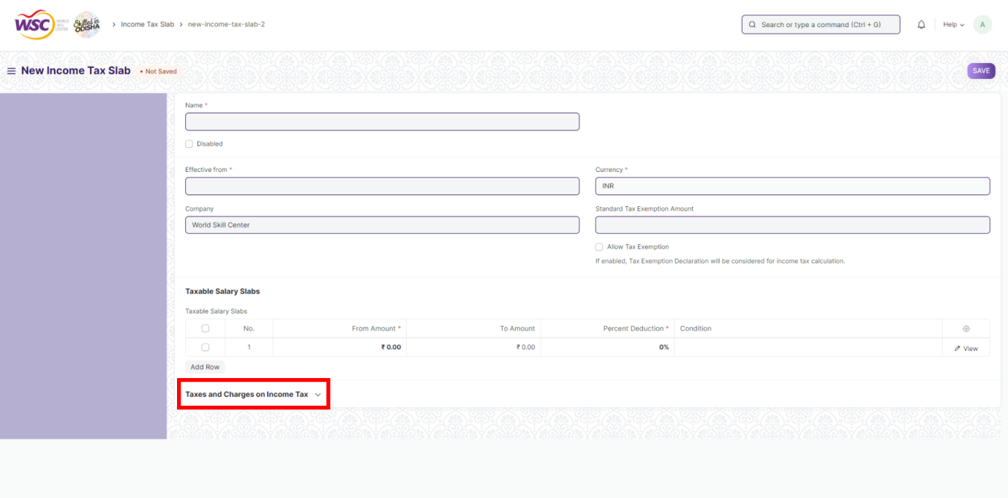

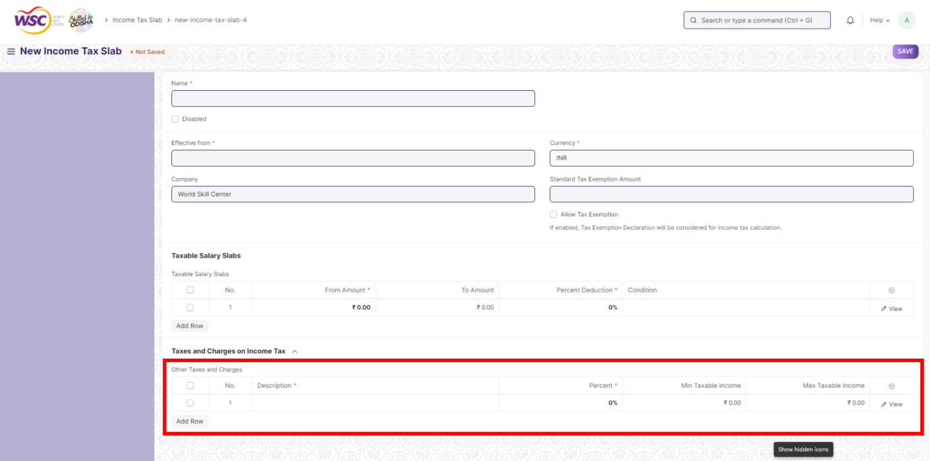

5. ***Save*** & ***Submit***

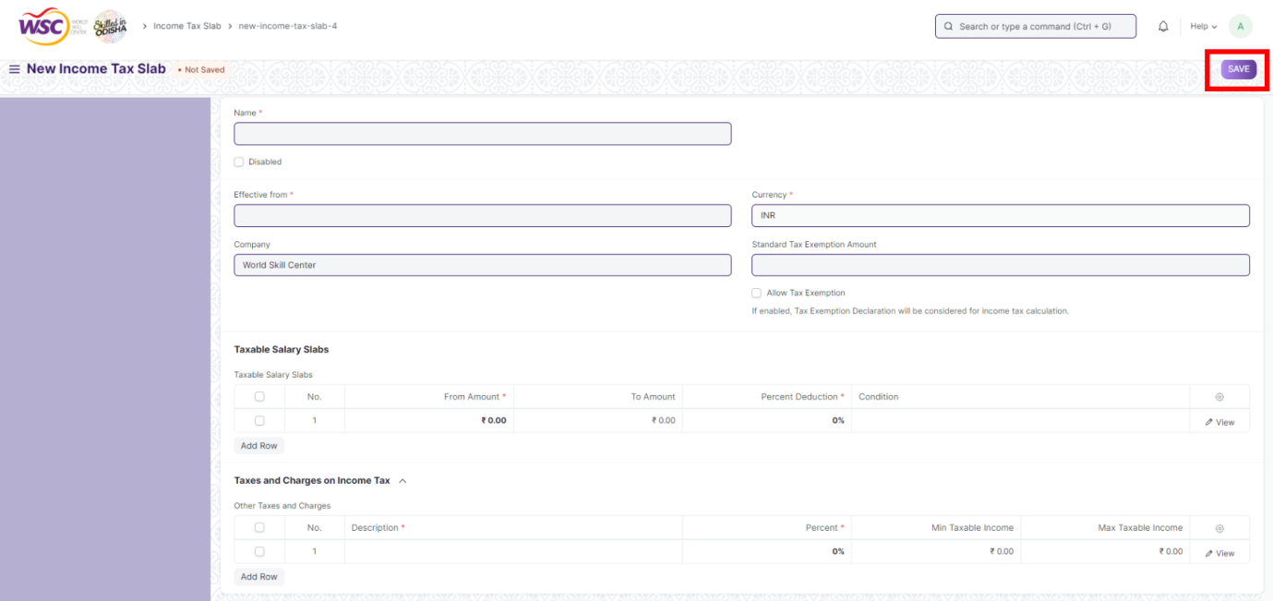

**4. Payroll Period :-**

A Payroll Period is a period for which Employees get paid for their occupation with the Company. Payroll Period helps you define Salary Structures and to calculate tax for a specific period based on applicable Income Tax Slab.

**>>> To access Payroll Period, go to :-**

***Home > Human Resources > Payroll > Payroll Period***

**>>> How to create a Payroll Period :-**

1. Go to ***Payroll Period*** list, click on ***+ Add Payroll Period***

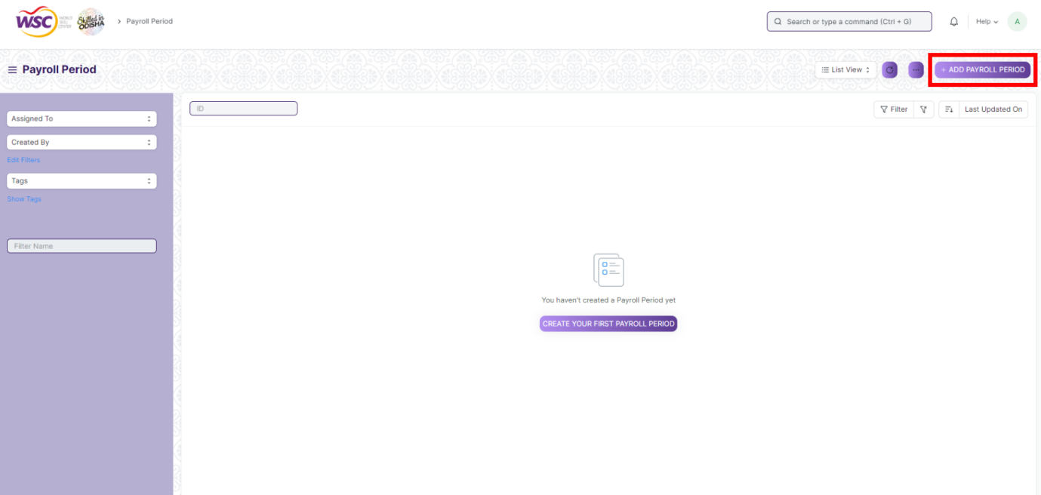

2. Enter ***Name***

3. Select ***Start Date*** and ***End Date***

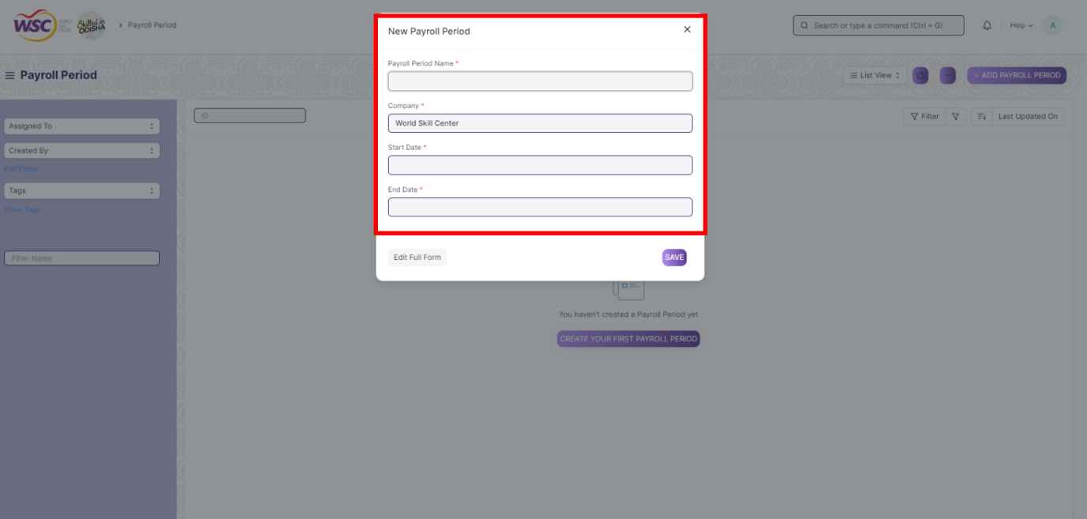

4. ***Save*** & ***Submit***

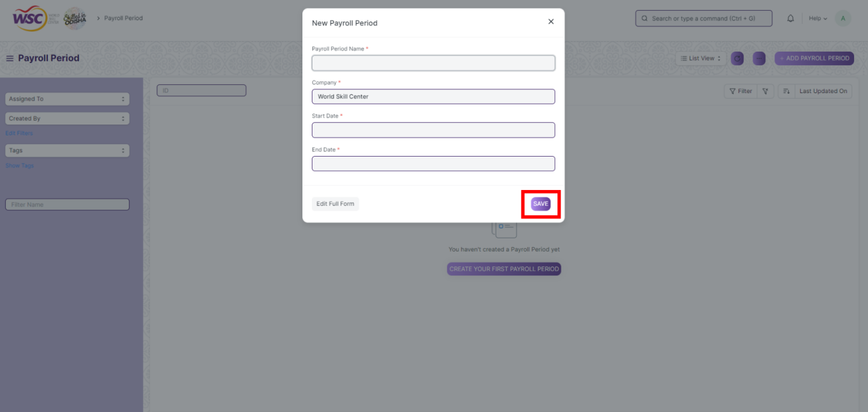

1. **Salary Structure Assignment :-**

Salary Structure Assignment form allows you to assign a particular Salary Structure to the employee.

**>>> To access Salary Structure Assignment, go to :-**

***Home > Human Resources > Payroll > Salary Structure Assignment***

**>>> Prerequisites :-**

Before you create a Salary Structure Assignment, it is advisable you have the following documents:

***1. Employee***

***2. Salary Component***

***3. Salary Structure***

**>>> How to create a Salary Structure Assignment :-**

1. Go to ***Salary Structure Assignment*** list and click on ***+ Add Salary Structure Assignment***

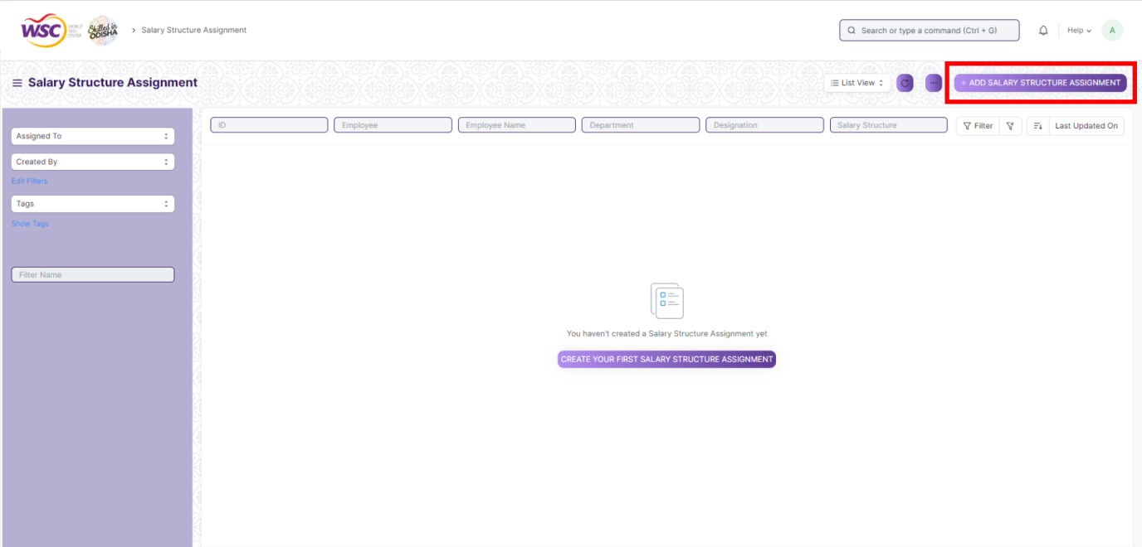

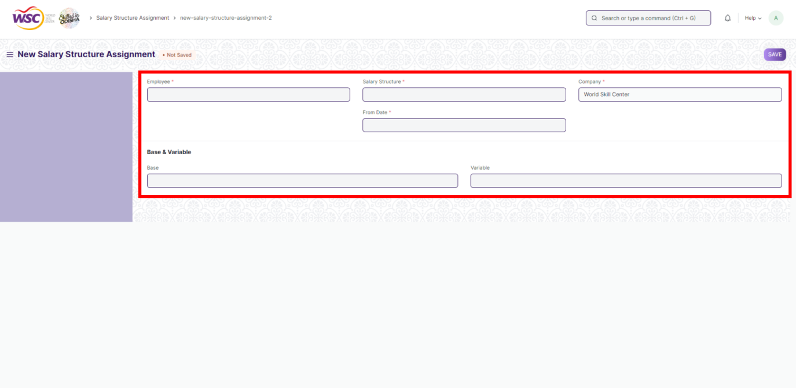

2. Select ***Employee*** and ***Salary Structure***

3. Select ***From Date***

4. Select preferred ***Income Tax Slab*** for the employee.

5. Enter ***Base*** and ***Variable*** amount as per requirement.

6. Save & Submit

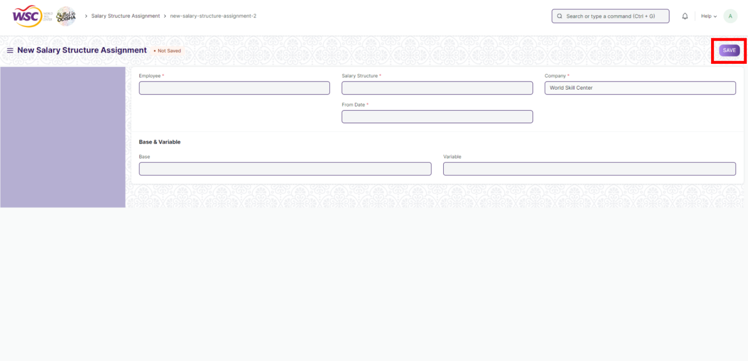

Base amount refers to the Base Salary of the Employee, which is fixed and paid out, regardless of employees meeting their goals. Variable pay, on the other hand, is the portion of sales compensation determined by employee performance. When employees hit their goals (aka quota), variable pay is provided as a type of bonus, incentive pay, or commission.

**06. Payroll Entry :-**

Payroll is the sum total of all compensation a business must pay to its employees for a set period of time or on a given date.

**>>> To access Payroll Entry, go to :-**

***Home > Human Resources > Payroll > Payroll Entry***

**>>> How to create a Payroll Entry :-**

**>> In Overview Section :-**

1. Go to ***Payroll Entry*** list, click on ***+ Add Payroll Entry***

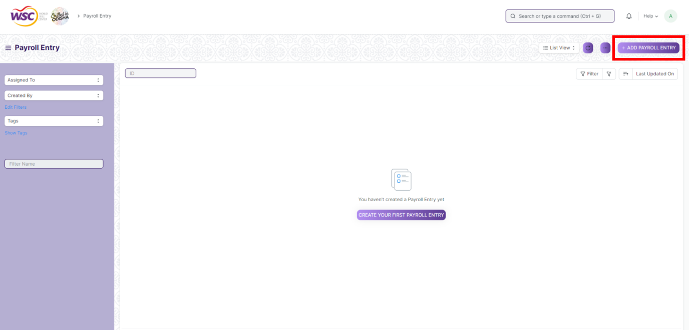

2. Select ***Payroll Frequency,*** ***Start Date*** & ***End Date*** will be set as per payroll frequency.

3. ***Attach*** Attendance Sheet for Validation

4. If Salary Slip is based on Time-sheet, check the check box ***Salary Slip Based on Timesheet***

5. Check the check-box ***Deduct Tax For Unclaimed Employee Benefits***

6. Check the check-box ***Deduct Tax For Unsubmitted Tax Exemption Proof***

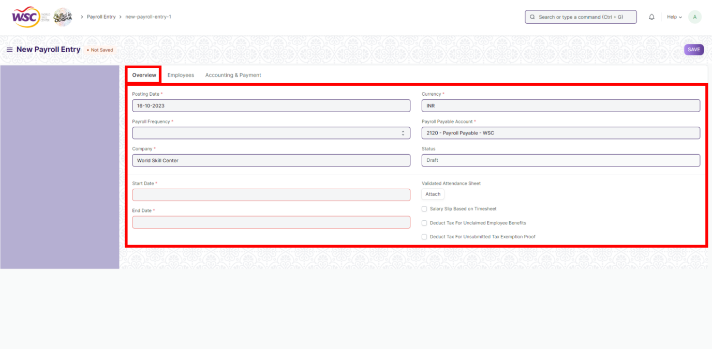

**>> In Employee Section :-**

4. Select ***Campus Location***, ***Designation***, ***Department***

5. Select ***Employees*** (Employee Name, Department, Designation will be set as per Employee)

6. Check ***Validate Attendance*** and ***Salary Slip Based on Timesheet*** check boxes in case you want to deduct the salary based on attendance and if you want to also consider the time sheets of the employees respectively.

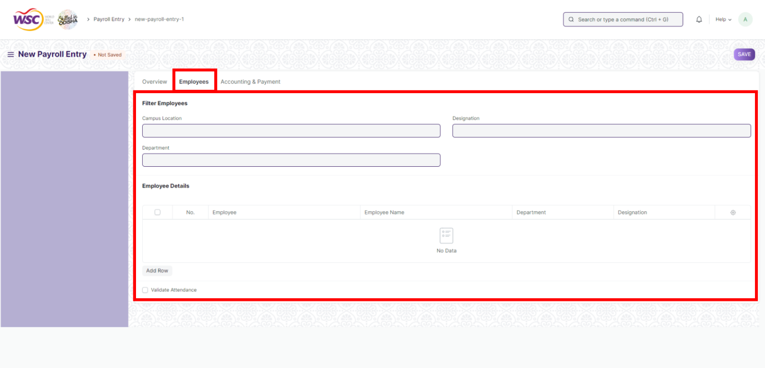

**>> Accounting & Payment Section :-**

7. Select ***Address***, ***About Us Team Member***, ***Article***, ***Project***, ***Payment Account*** & ***Bank Account***

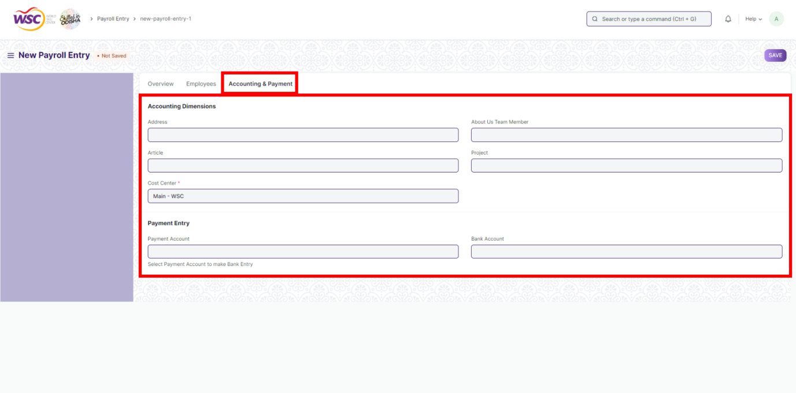

8. Save

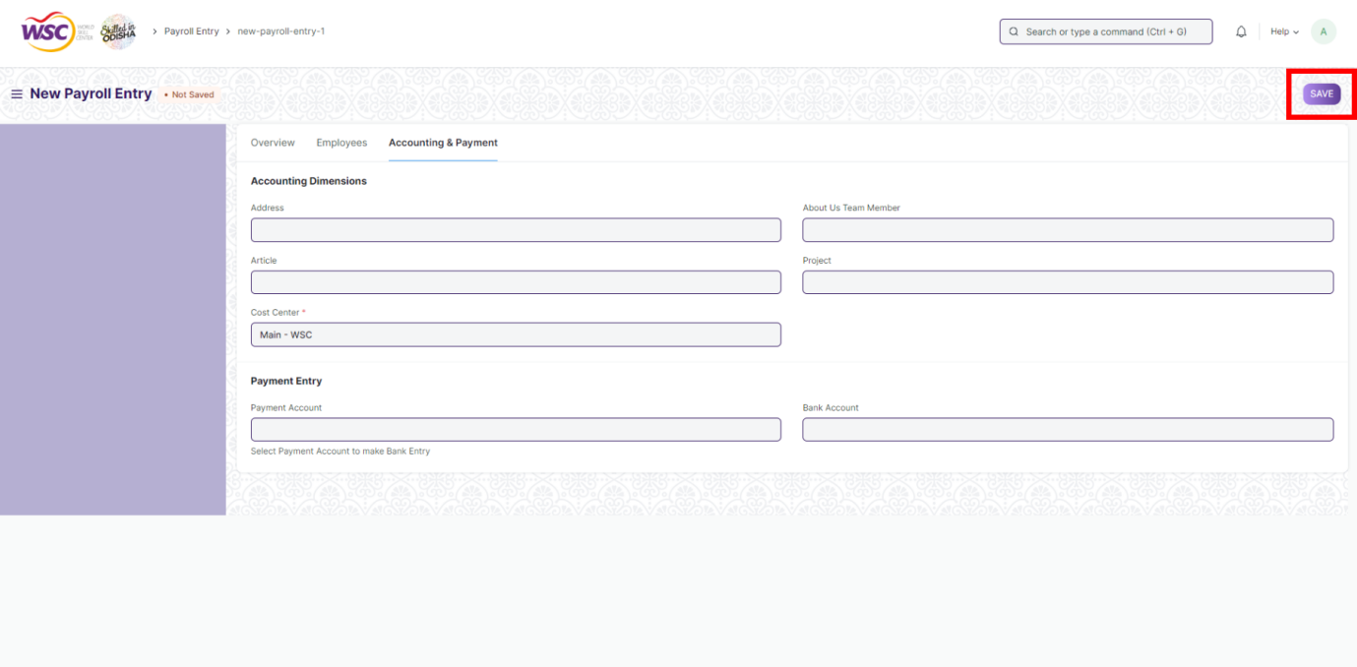

9. Once saved, Click on ***Create Salary Slip***

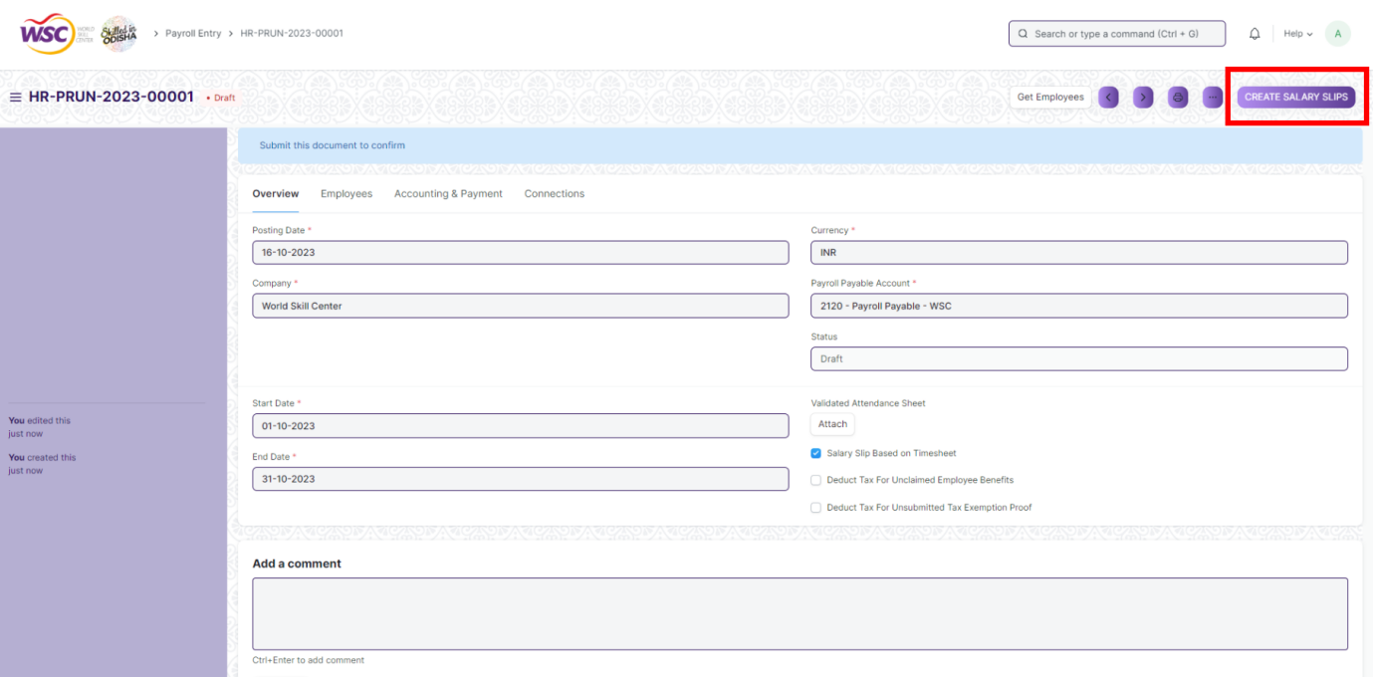

**08. Employee Other Income :-**

Employee Other Income is a document to declare other income of an employee from different sources. It is important to calculate the income tax liability of an employee. In Frappe HR, an employee can declare their other income using this document.

**>>> To access Employee Other Income, go to :-**

***Home > Human Resources > Employee Tax and Benefits > Employee Other Income***

**>>> How to create an Employee Other Income :-**

1. Go to Employee Other Income. Click on ***+ Add Employee Other Income***

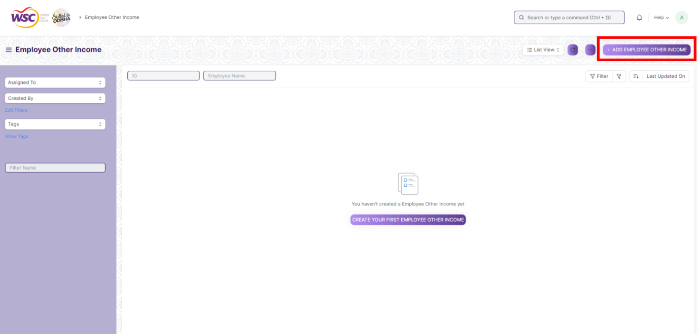

2. Select ***Employee*** & ***Payroll Period***

3. Enter ***Amount***

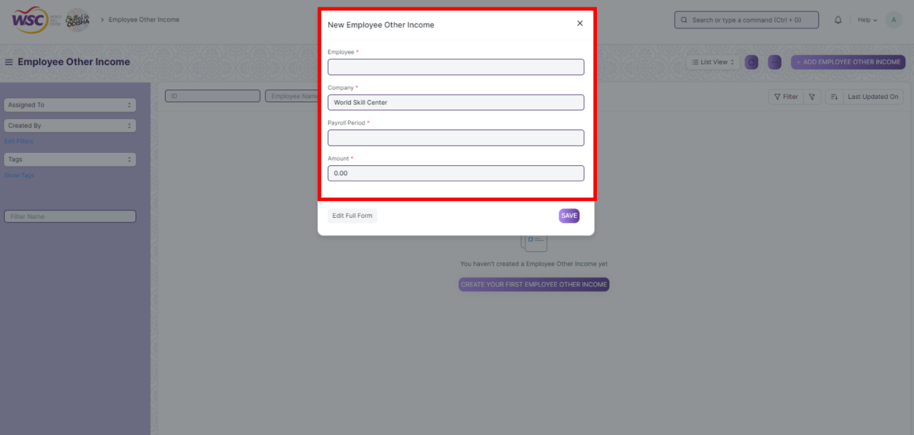

4. Save & Submit

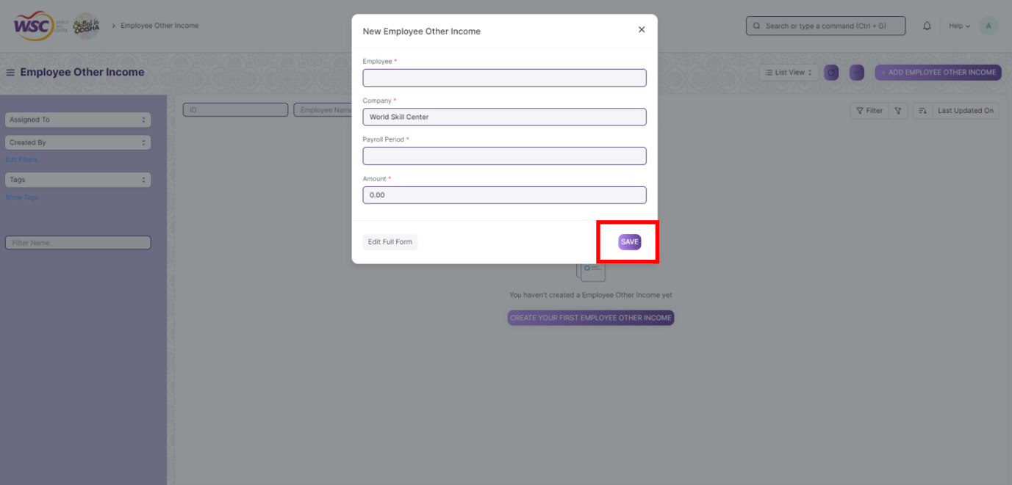

**09. Employee Tax Exemption Declaration :-**

Tax exemption is the monetary exemption of income, property or transactions from taxes that would otherwise be levied on an Employee. At the beginning of a Payroll Period, employees can declare the amount of exemption they will be claiming from their taxable salary. Frappe HR allows you to specify tax exemption category/sub-category, tax exemption amount and other related information in the Employee Tax Exemption Declaration form.

**>>> To access Employee Tax Exemption Declaration go to :-**

***Home > Human resources > Employee Tax and Benefits > Employee Tax Exemption Declaration***

**>>> Prerequisites :-**

Before creating an Employee Tax Exemption Declaration, it is advisable you create the following:-

***1. Employee***

***2. Employee Tax Exemption Category***

***3. Employee Tax Exemption Sub Category***

**>>> How to create Employee Tax Exemption Declaration :-**

1. Go to Employee Tax Exemption Declaration. Click on ***+ Add Employee Tax Exemption Declaration***

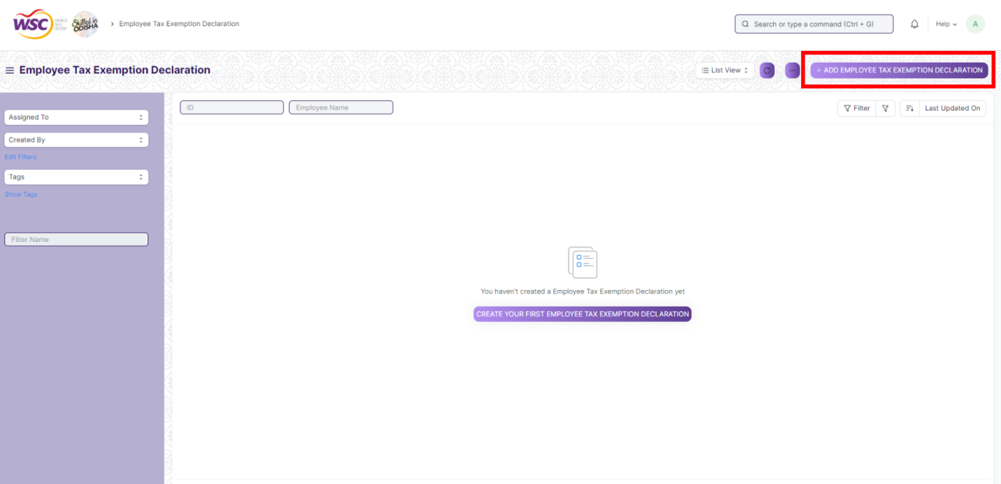

**>> In Details :-**

1. Select ***Employee*** & ***Payroll Period***

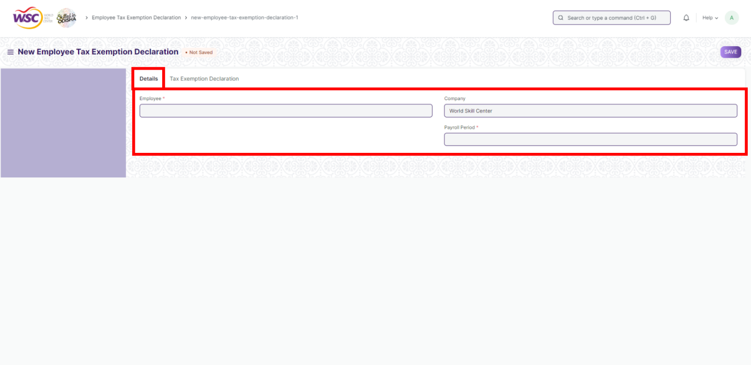

3. Select ***Exemption Sub Category*** & ***Exemption Category***

4. Enter ***HRA Exemption Amount***

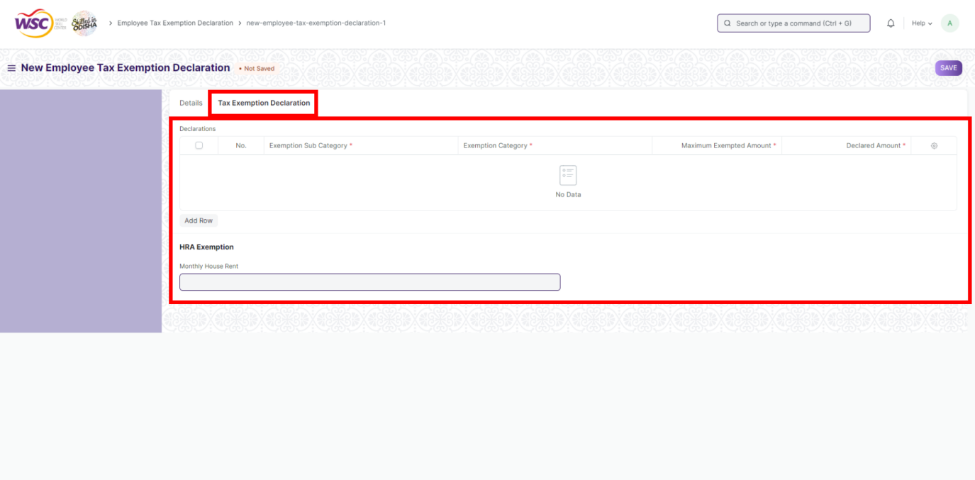

5. Save & Submit

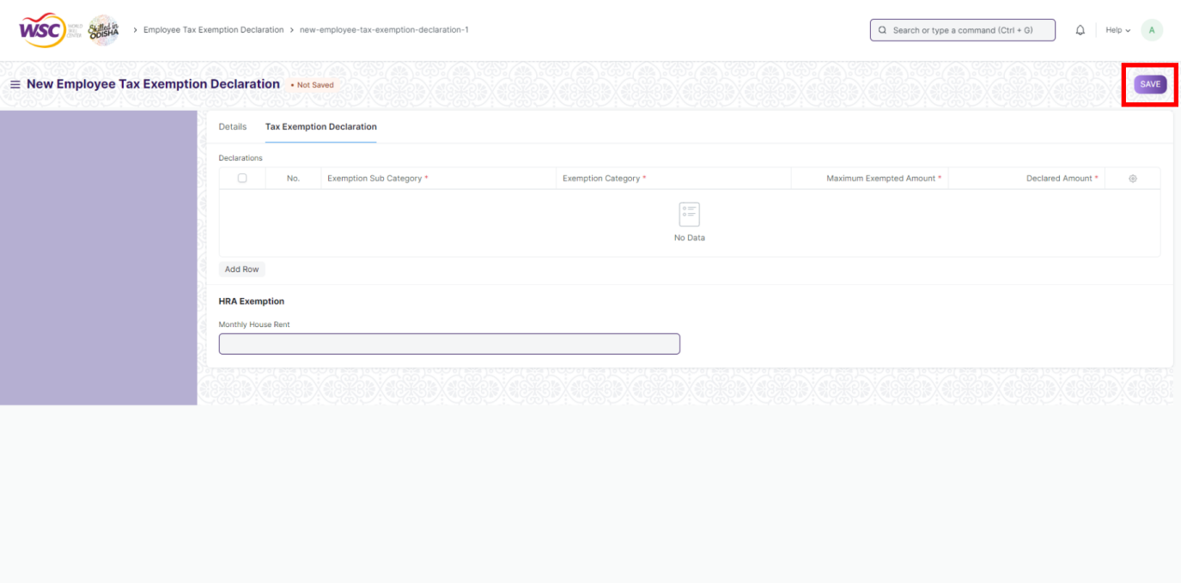

**10. Employee Tax Exemption Proof Submission :-**

Employees are required to submit proofs for all the spending they claim tax exemption for. This can be done through the Employee Tax Exemption Proof Submission document This is usually done at the end of a Payroll Period, but employees can submit any number of proofs unlike Employee Tax Exemption Declaration.

**>>> Prerequisites :-**

***1. Employee Tax Exemption Declaration***

**>>> To access Employee Tax Exemption Proof Submission, go to :-**

***Home > Human resources > Employee Tax Exemption Proof Submission***

**>>> How to create an Employee Tax Exemption Proof Submission :-**

The details are already fetched if you click on 'Submit Proof' from Employee Tax Exemption Declaration. However, if you want to create an 'Employee Tax Exemption Proof Submission' manually, follow these steps.

1. Go to the Employee Tax Exemption Proof Submission list, click on ***+ Add Employee Tax Exemption Proof Submission***

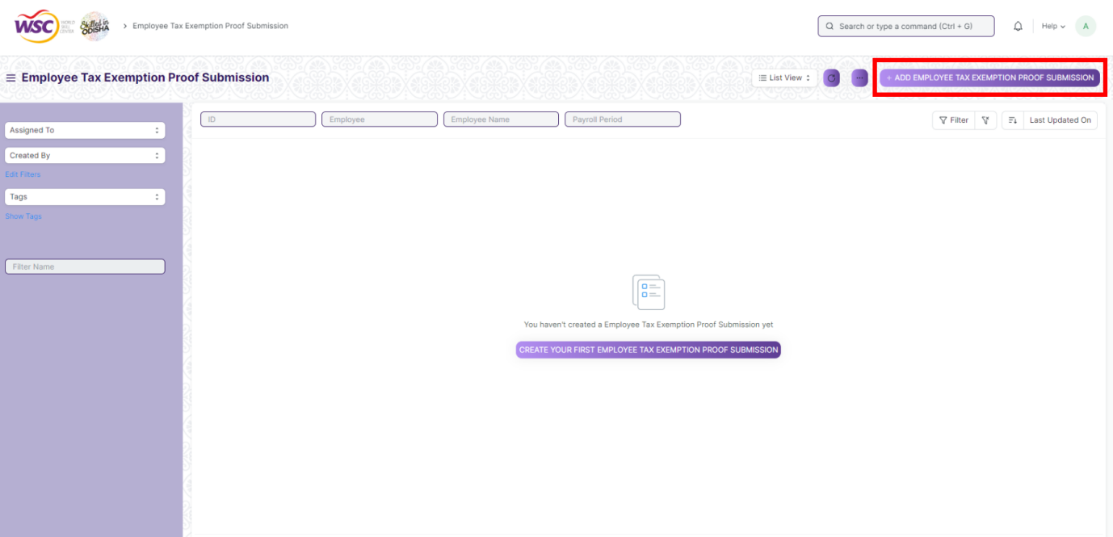

**>> In Detail :-**

1. Select ***Employee*** & ***Payroll Period***

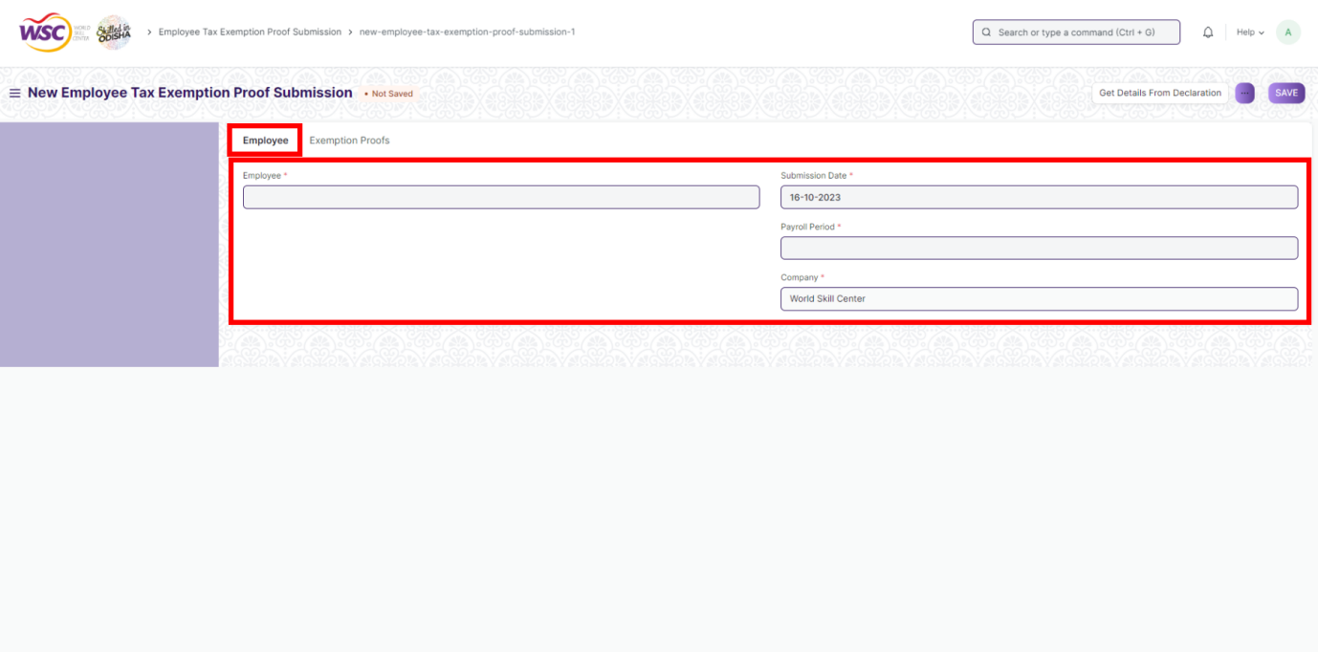

**>> In Exemption Proofs :-**

3. Select ***Exemption Sub Category*** & ***Exemption Category***

4. Enter ***HRA Exemption Amount***

5. Enter ***Type of Proof***

6. ***Attach*** the proof in by clicking on the Attach button at the bottom

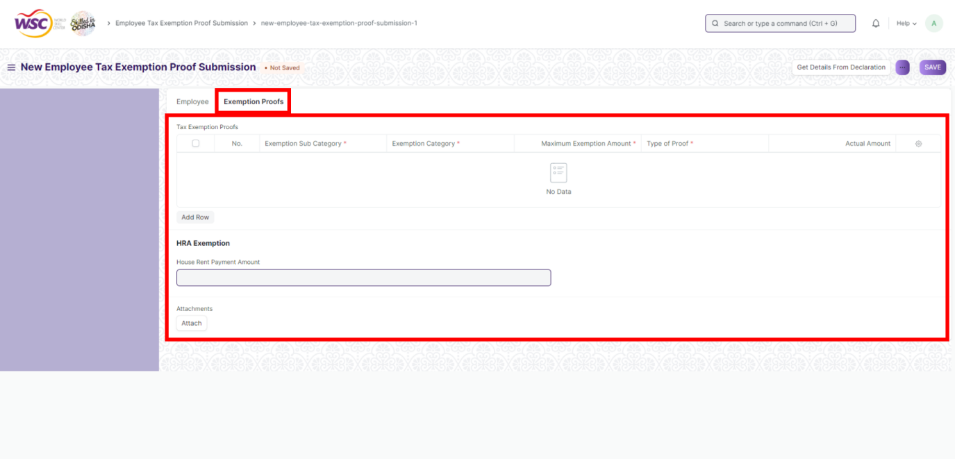

7. Save & Submit

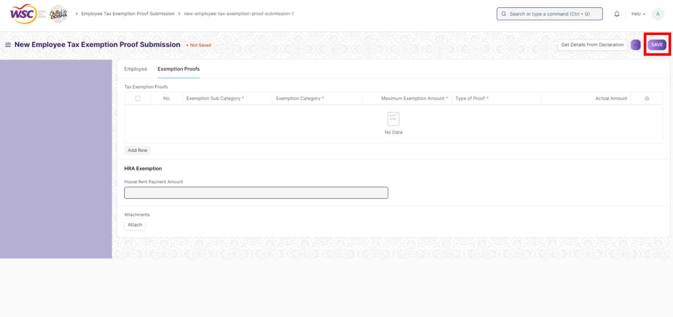

**11. Employee Tax Exemption Category :-**

Exemptions from taxable salary are usually restricted to spending on particular categories decided by the Government or regulatory agencies. Frappe HR allows you to configure various categories which are allowed to be exempted. Examples of these (for India) could be, 80G, 80C, B0CC etc.

**>>> You can configure Employee Tax Exemption Category by going to :-**

***Employee Tax and Benefits > Employee Tax Exemption Category***

***>>> How to create Employee Tax Exemption Category :-***

1. Go to the Employee Tax Exemption Category list, click on ***+ Add New Employee Tax Exemption Category***

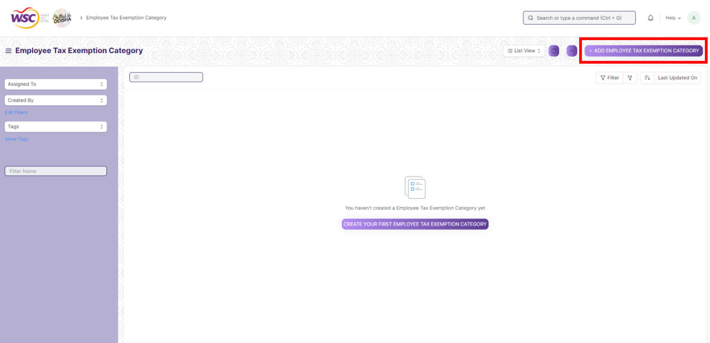

1. Enter ***Name*** & ***Max. Exemption Amount***

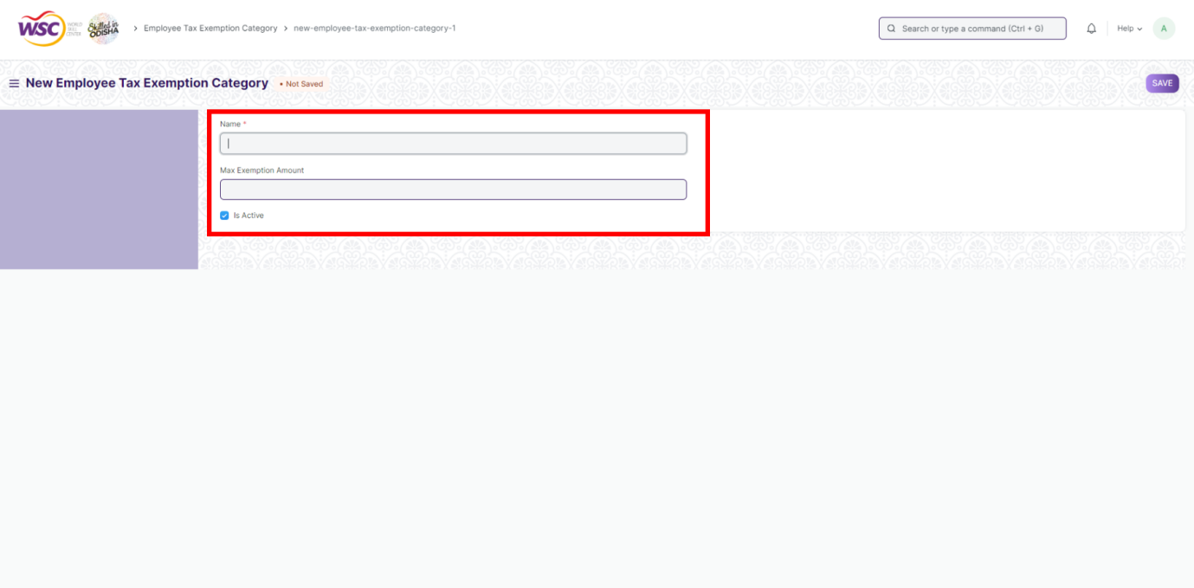

1. Save & Sumbit

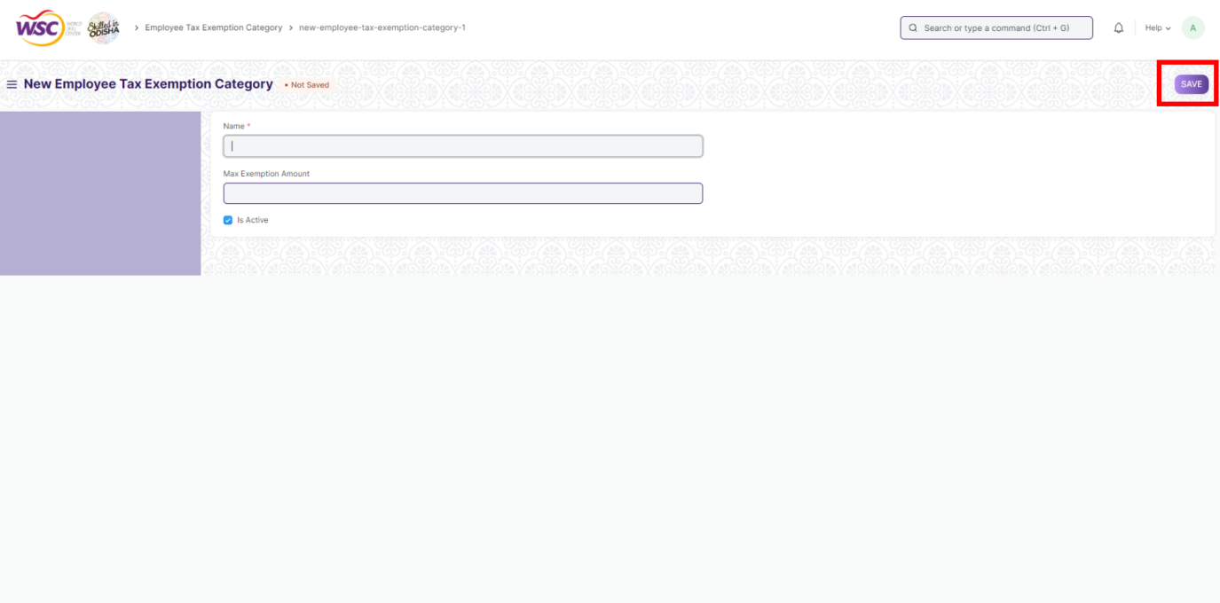

**12. Employee Tax Exemption Sub Category :-**

Under each category, there could be many heads for which the exemptions are allowed. For example, in India, sub categories under 80C could be Life Insurance Premium

**>>> You can configure Employee Tax Exemption Category by going to :-**

***Employee Tax and Benefits > Employee Tax Exemption Sub-Category***

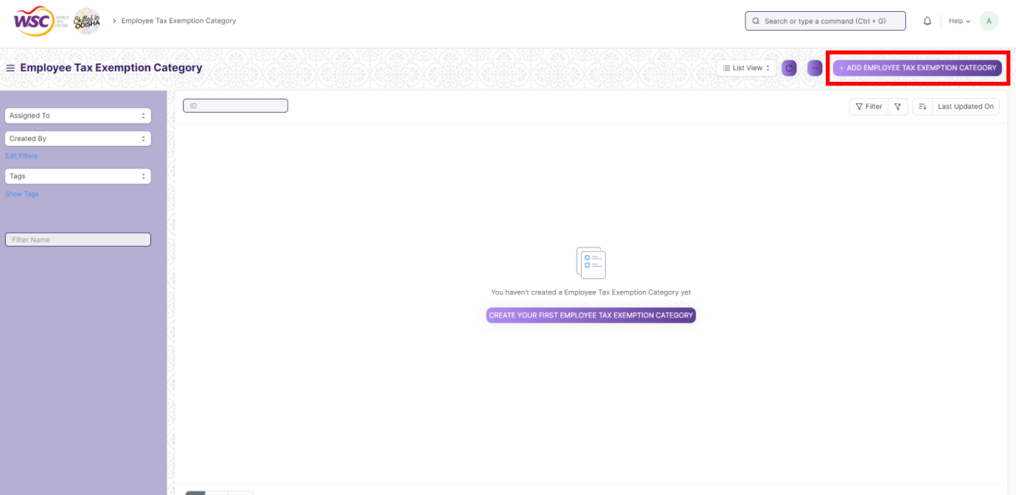

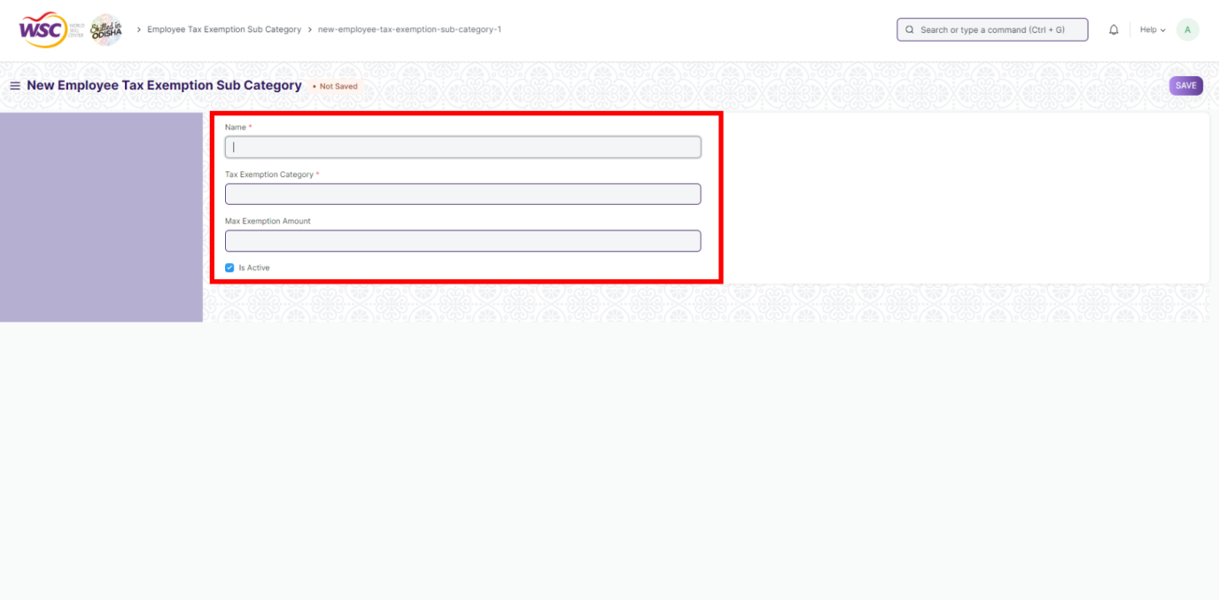

**13. Journal Entry :-**

**>>> How to create a Journal Entry :-**

1. Go to Journal Entry List. Click on ***+ Add Journal Entry***

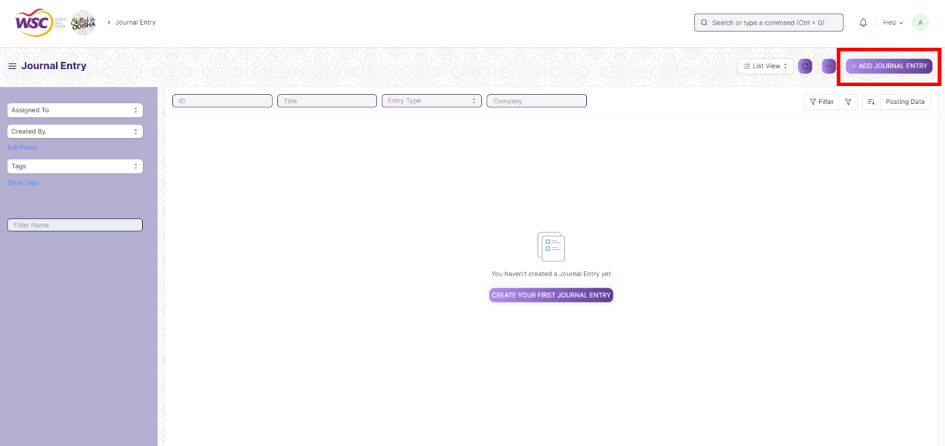

1. Enter ***From Template*** (Optional)

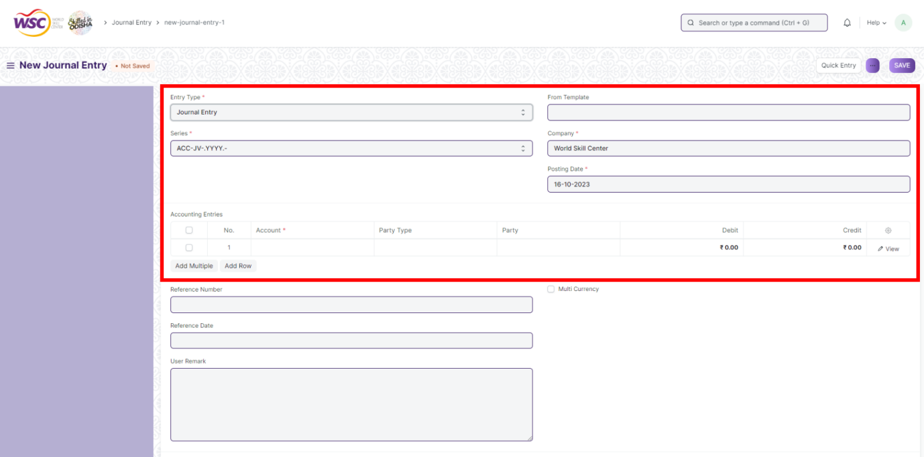

1. Enter ***Reference Number*** (Optional),Select ***Reference Date*** (Optional) & Enter ***User Remarks*** (Optional)
2. Check ***Multi Currency*** if currency is not INR.

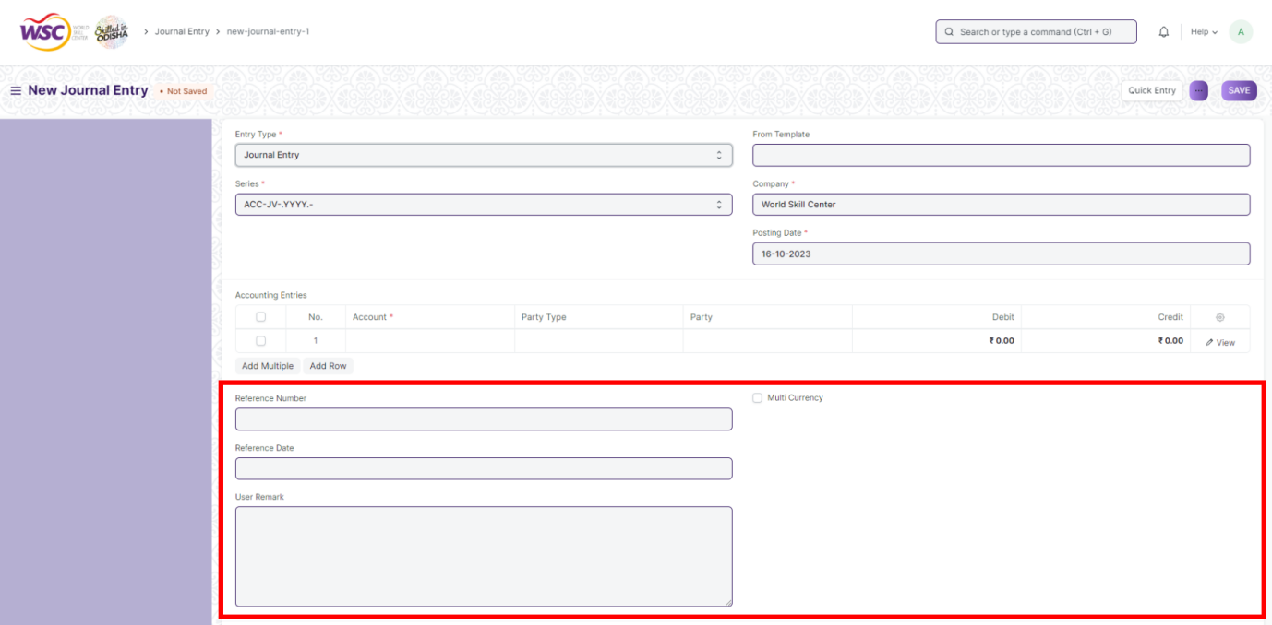

**>> In Accounting Entries :-**

1. Click on ***View***.

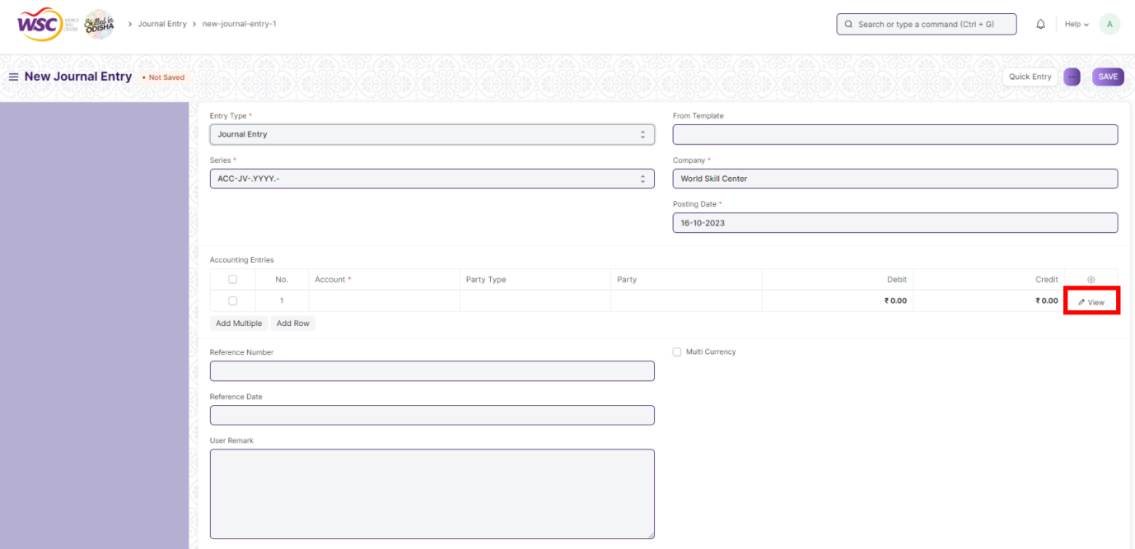

1. Enter ***Account***, ***Account Balance***, ***Bank Account***, ***Party Type***, ***Party***

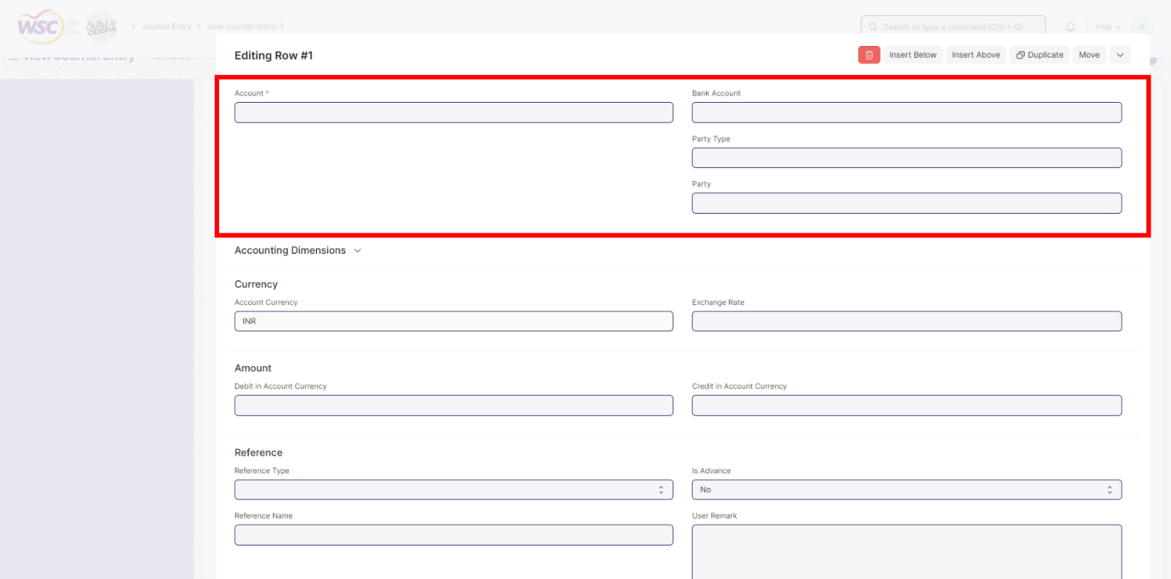

1. Click on ***Accounting Dimension***

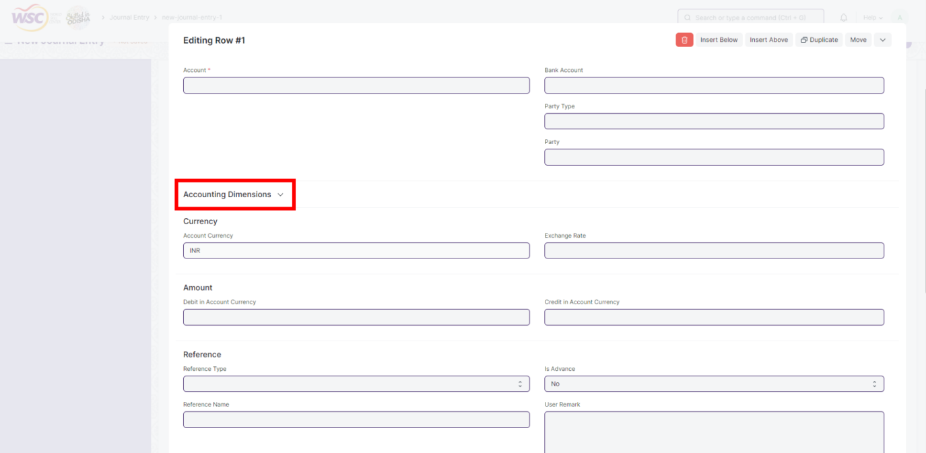

1. Select ***Cost Center*** & ***Project***

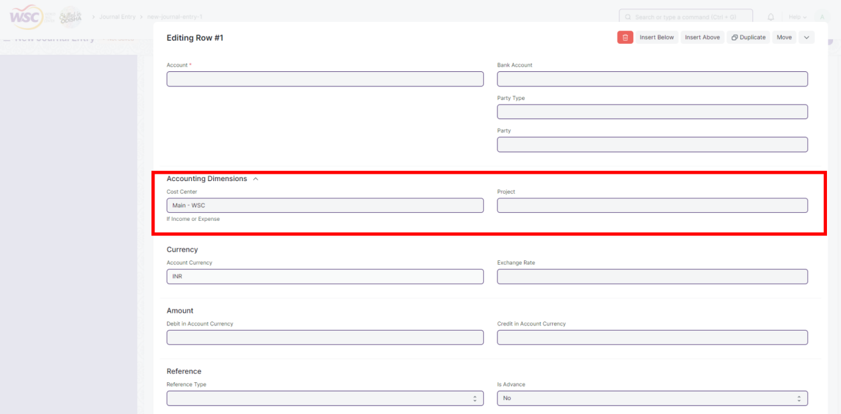

1. If ***Multi Currency*** has been checked, in Currency section Enter ***Exchange Rate***.

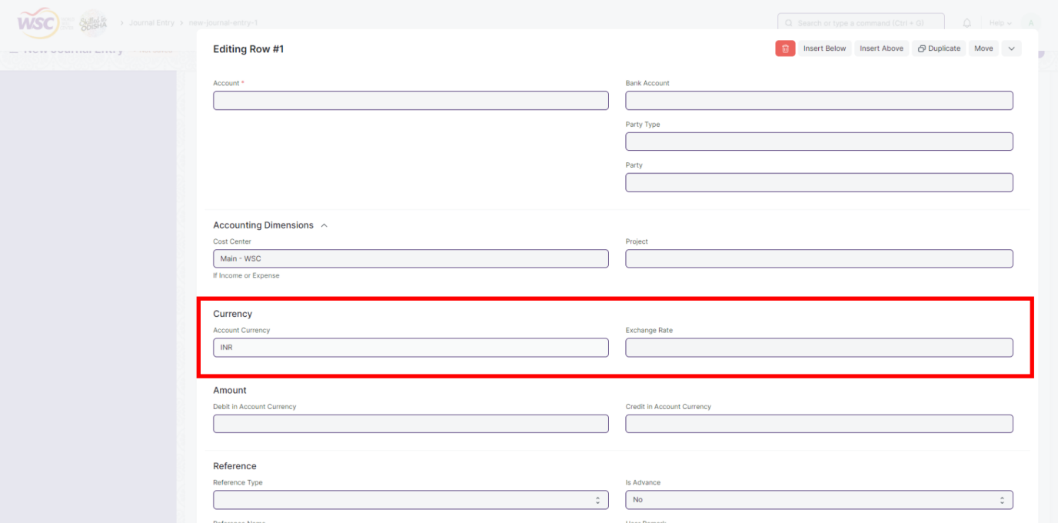

1. In Amount Section Enter ***Debit*** & ***Credit***. If ***Multi Currency*** has been selected Enter ***Debit in Account Currency*** & ***Credit in Account Currency***.

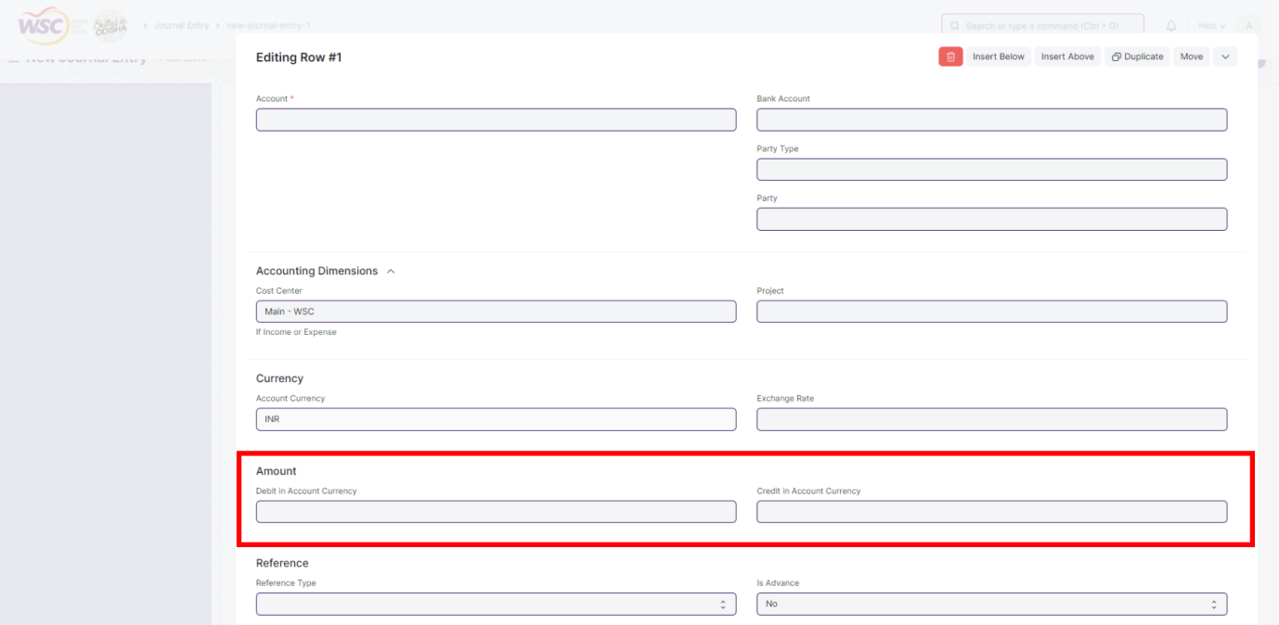

1. In Reference Section Enter ***Reference Type***, ***Reference Name*** & ***User Remark*** (Optional)

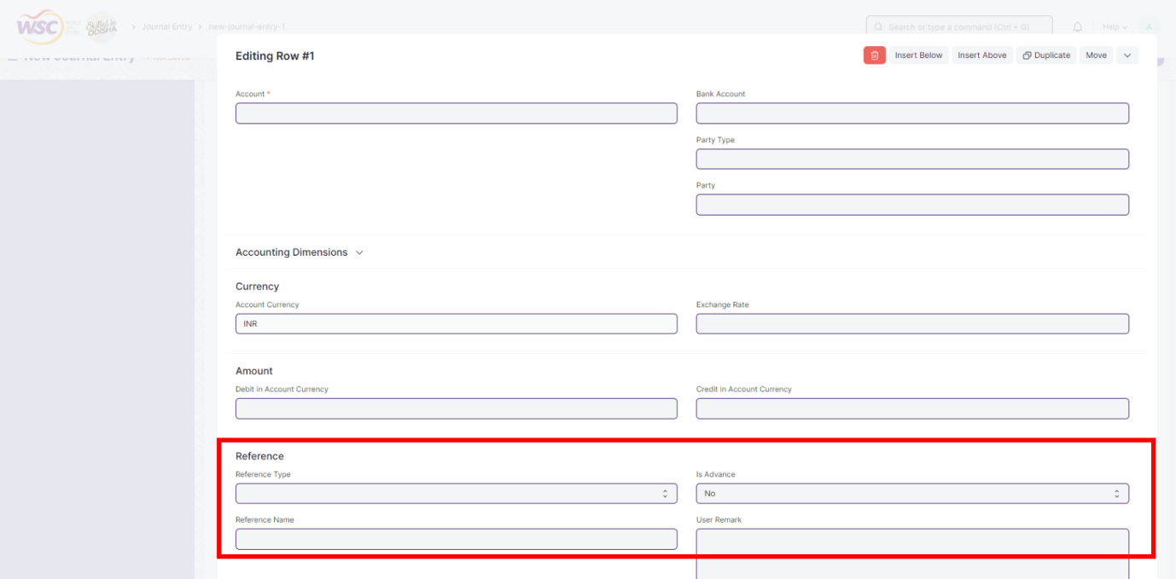

**14. Additional Salary :-**

Additional Salary is something that an Employee receives from the company they work for, other than their usual pay.

Additional Salary is to add or deduct ad hoc salary for a particular Employee while processing the Payroll. Some examples of Additional Salary could be Performance Bonus, Deputation Allowance, Arrears, Incentives, or other adjustments.

**>>> To access Additional Salary, go to :-**

***Home > Human Resources > Payroll > Additional Salary***

**>>> Prerequisites:-**

Before creating an Additional Salary, it is advisable to create the following :-

1. ***[Employee](https://frappehr.com/docs/v14/user/manual/en/human-resources/employee)***
2. ***[Salary Component](https://frappehr.com/docs/v14/user/manual/en/human-resources/salary-component)***

**>>> How to create an Additional Salary:-**

1. Go to the Additional Salary list, click on ***+ Add Additional Salary***

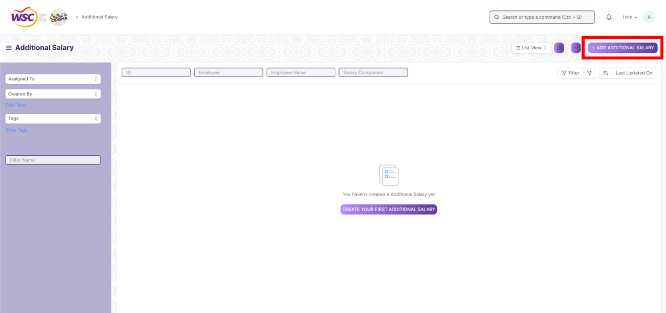

1. Select ***Employee*** & ***Salary Component***
2. Enter ***Amount,*** & ***Payroll Date***

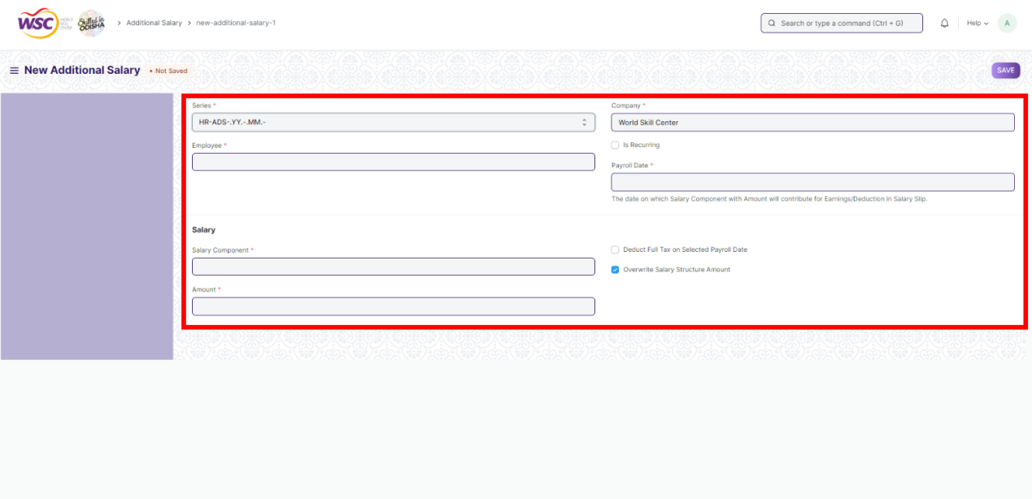

If Payroll Date for Additional Salary is in the interval when the salary is processed, it will be added to the earnings/deduction.

1. Save & Submit

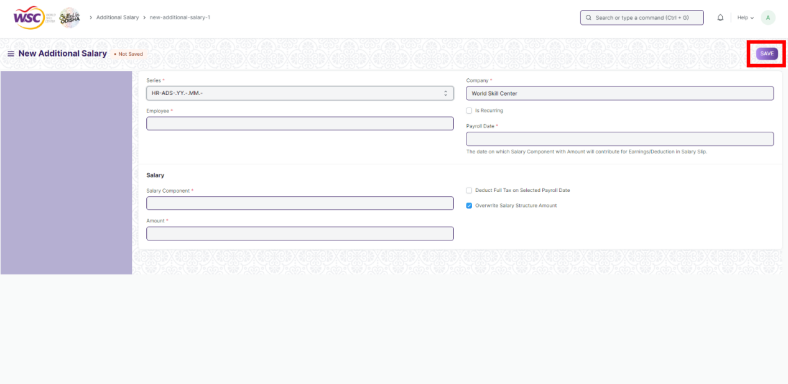

Select the ***Overwrite Salary Structure Amount*** checkbox to overwrite the Additional Salary component on the Salary Structure amount. Additionally, the ***Deduct Full Tax on Selected Payroll Date*** checkbox can be selected if full tax needs to be deducted on the Additional Salary component for that particular payroll date.

1. **Retention Bonus :-**

Retention bonus is a payment or reward outside of an employee's regular salary that is offered as an incentive to keep a key employee on the job.

**>>> To access Retention Bonus, go to :-**

***Home > Human Resources > Payroll > Retention Bonus***

**>>> Prerequisites:-**

Before creating a Retention Bonus, it is advisable to create the following :-

1. ***[Employee](https://frappehr.com/docs/v14/user/manual/en/human-resources/employee)***
2. ***[Salary Component](https://frappehr.com/docs/v14/user/manual/en/human-resources/salary-component)***

**>>> How to create a Retention Bonus:-**

1. Go to Retention Bonus list, click on ***+ Add Retention Bonus***

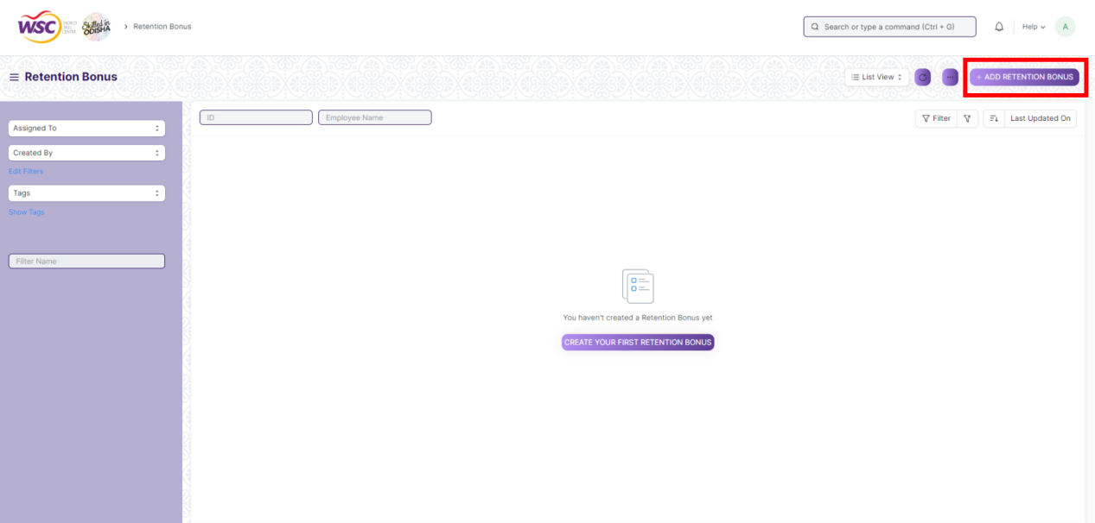

1. Select ***Employee, Salary Component, Bonus Amount & Bonus Payment Date***

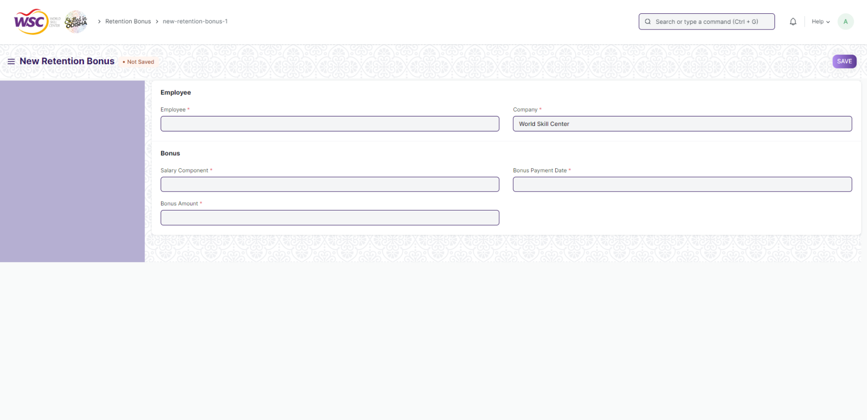

1. Save & Submit



On submit, 'Additional Salary' document of the specified 'Salary Component' is created. This will be fetched while running Payroll Entry.

**16. Employee Incentive :-**

Employee Incentives are a way of compensating and motivating employee performance apart from the usual salary.

When an organization wants to encourage productivity among its employees, one of the options available is rewarding the Employee with an incentive. Frappe HR allows you to create Employee Incentives as and when required for a particular payroll entry.

**>>> To access Employee Incentive, go to :-**

***Home > Human Resources > Payroll > Employee Incentive***

**>>> Prerequisites:-**

Before creating an Employee Incentive, it is advisable to create the following :-

1. ***[Employee](https://frappehr.com/docs/v14/user/manual/en/human-resources/employee)***
2. ***[Salary Component](https://frappehr.com/docs/v14/user/manual/en/human-resources/salary-component)***

**>>> How to create an Employee Incentive:-**

1. Go to Employee Incentive list, click on ***+Add Employee Incentive***

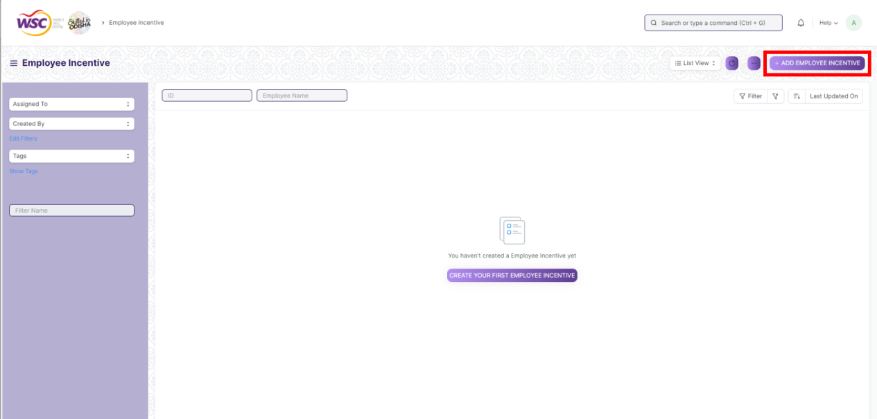

1. Select the ***Employee, Salary Component, Payment Date & Enter Incentive Amount***

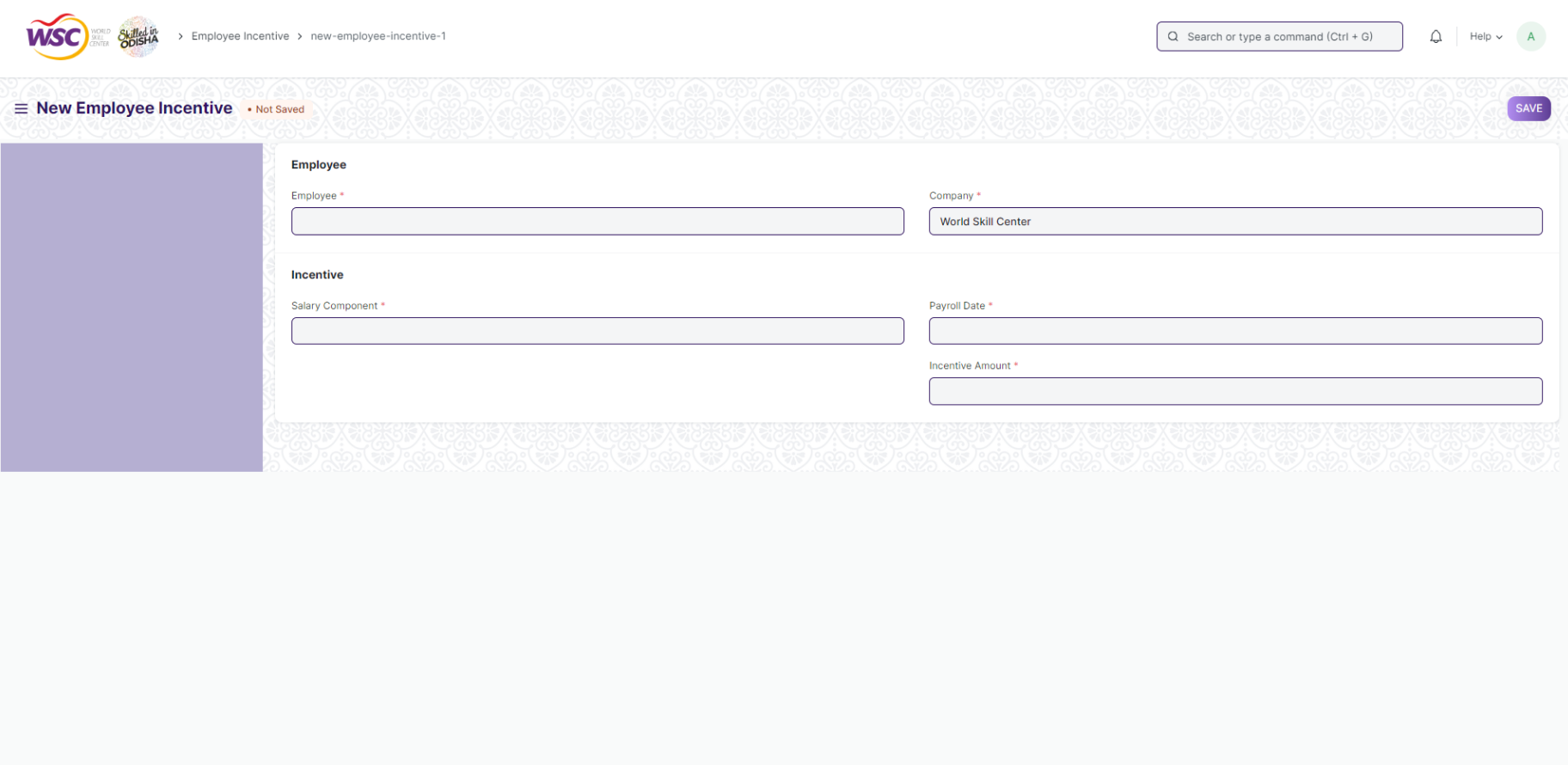

1. Save and Submit



On submit, the ***Additional Salary*** document of the specified ***Salary Component*** is created. This will be fetched while running the Payroll Entry.

**17. Employee Benefit Application :-**

Employees are entitled to flexible benefits which they can either receive pro-rata (as part of their Salary) or as a lump-sum amount when they claim the benefit. In order to choose from various flexible benefits which an Employee shall receive on a pro-rata basis, the employee should create a new Employee Benefit Application.

**>>> To create a new Employee Benefit Application :-**

***Human Resources > Payroll > Employee Benefit Application > New Employee Benefit Application***

**>>> How to create an Employee Benefit Application:-**

1. Go to Employee Benefit Application list, click on ***+ Add Employee Benefit Application***

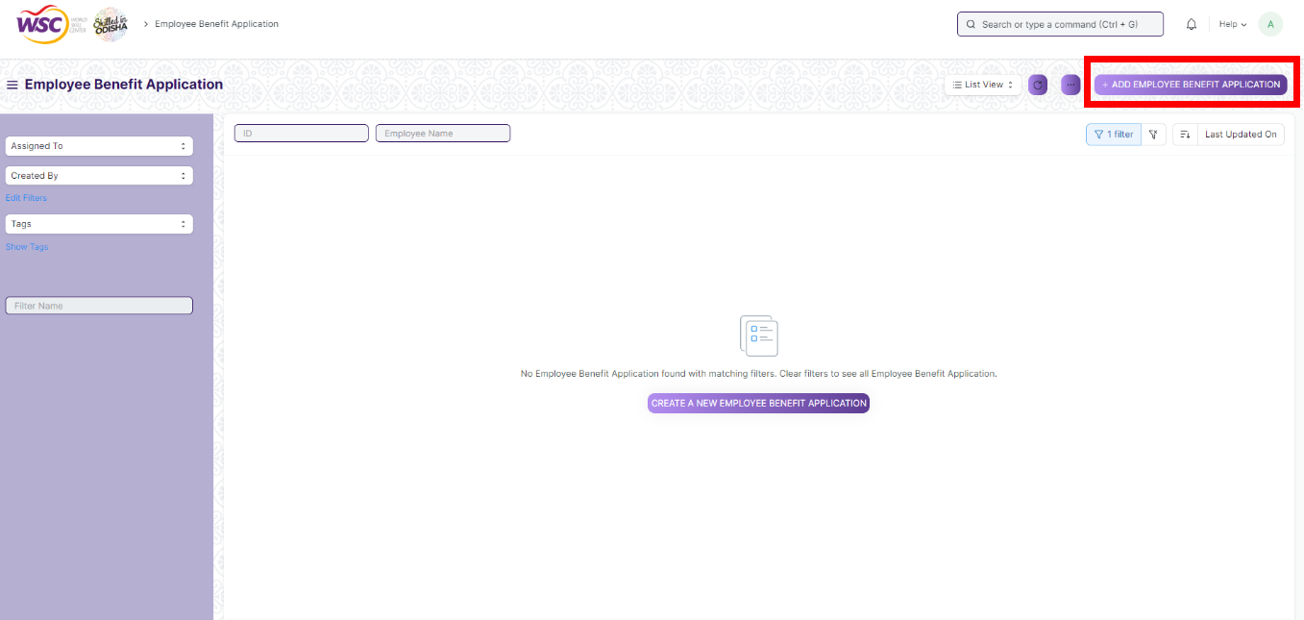

1. Select ***Employee***, ***Payroll Period***, ***Company***

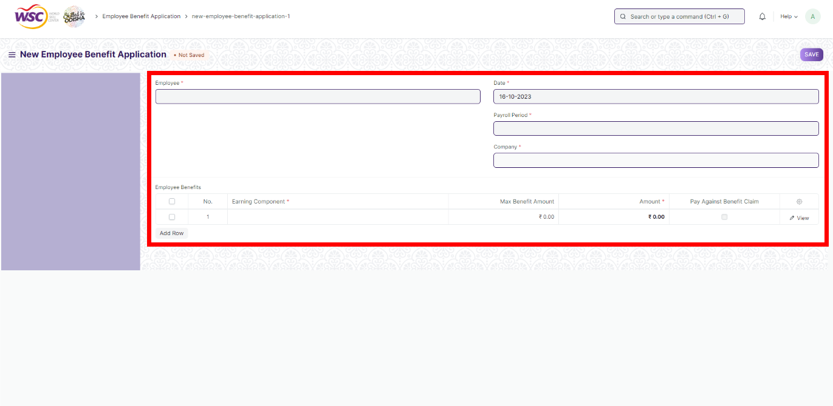

1. Save & Submit

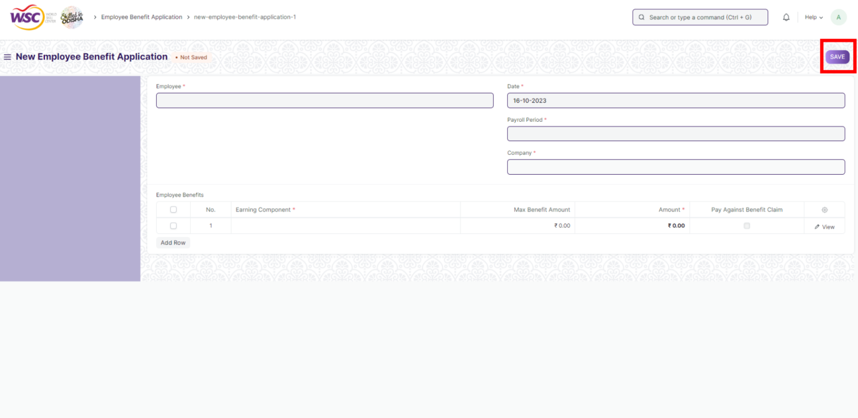

Here, Employee can view the Max Benefits as per the Salary Structure Assignment and then chose from the Earning Components which are part of the employee's assigned Salary Structure. They can also enter the amount which they wish to receive as part of their Salary Slip.

It is based on the Employee Benefit Application that the Max Benefit Amount will be distributed among the flexible earning components while generating the Salary Slip. If an Employee fails to submit the Employee Benefit Application before processing the payroll, the Max Benefit Amount eligible to the employee will be distributed proportionately to each of the flexible component present in the Employee's salary structure.

**Note :-** Employees can only submit one Employee Benefit Application for a Payroll Period.

Employee Benefit Application should cover the full amount which the employee has to receive as per the Max Benefit amount on a pro-rata basis. However, if the Salary Structure of the employee consists of Salary Components which are to be paid on Employee Benefit Claim (Salary Component with Pay Against Benefit Claim), they are allowed to submit Employee Benefit Application excluding the amount allocated for such components.

Also, note that those components which are to be received based on Employee Benefit Claims can also be part of the application, but will only be disbursed lump-sum, as part of their salary when the Employee submits a claim for it.

**Note :-** Normal Tax calculation does not include Flexible Benefits as in most cases these are exempted from Tax. To tax these components anytime before the last payroll, use Deduct Tax For Unclaimed Employee Benefits in Payroll Entry / Salary Slip while processing the Salary.

**18. Employee Benefit Claim :-**

Employee Benefit Claim allows Employees to

1. Claim flexible benefits which are to be received lump-sum (if Salary Component is Pay Against Benefit Claim)
2. Claim tax exemption for flexible benefits received pro-rata, as part of salary when Deduct Tax For Unclaimed Employee Benefits is checked in Payroll Entry / Salary Slip

**>>> You can create a new Employee Benefit Claim by going to :-**

***Human Resources > Payroll > Employee Benefit Claim > New Employee Benefit Claim***

**>>> How to create an Employee Benefit Claim:-**

1. Go to Employee Benefit Claim list, click on ***+ Add Employee Benefit Claim***

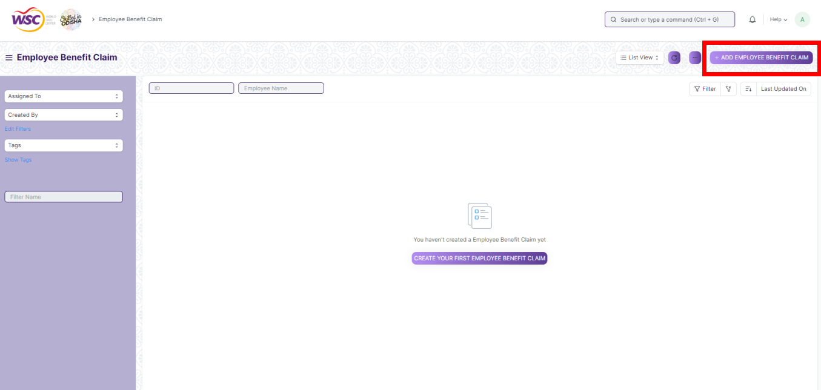

1. Select ***Employee*,** Select ***Claim Benefit For*,** Enter ***Claim Amount*,** Attach ***Expense Proof*.**

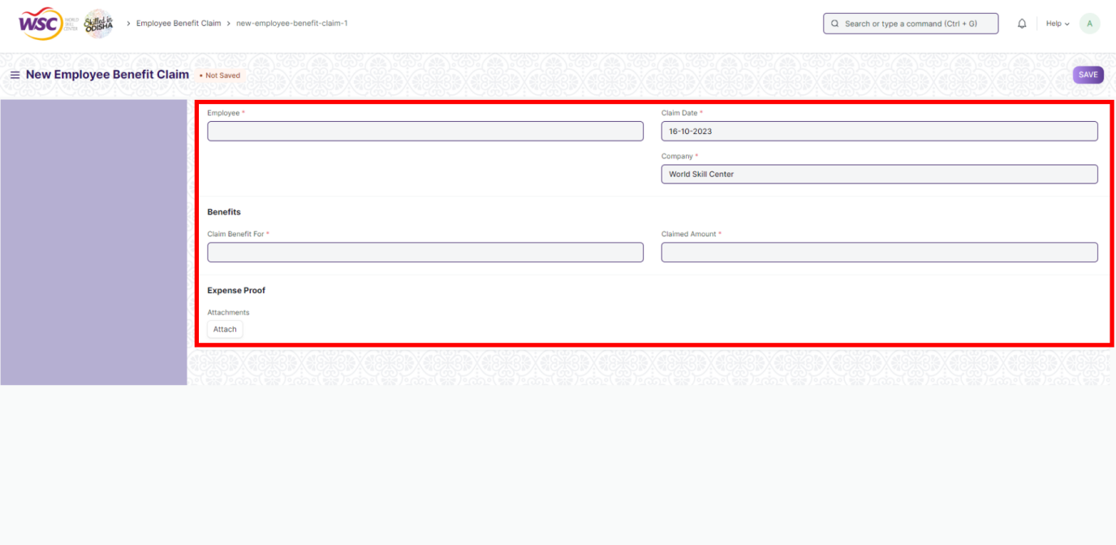

1. Save & Submit

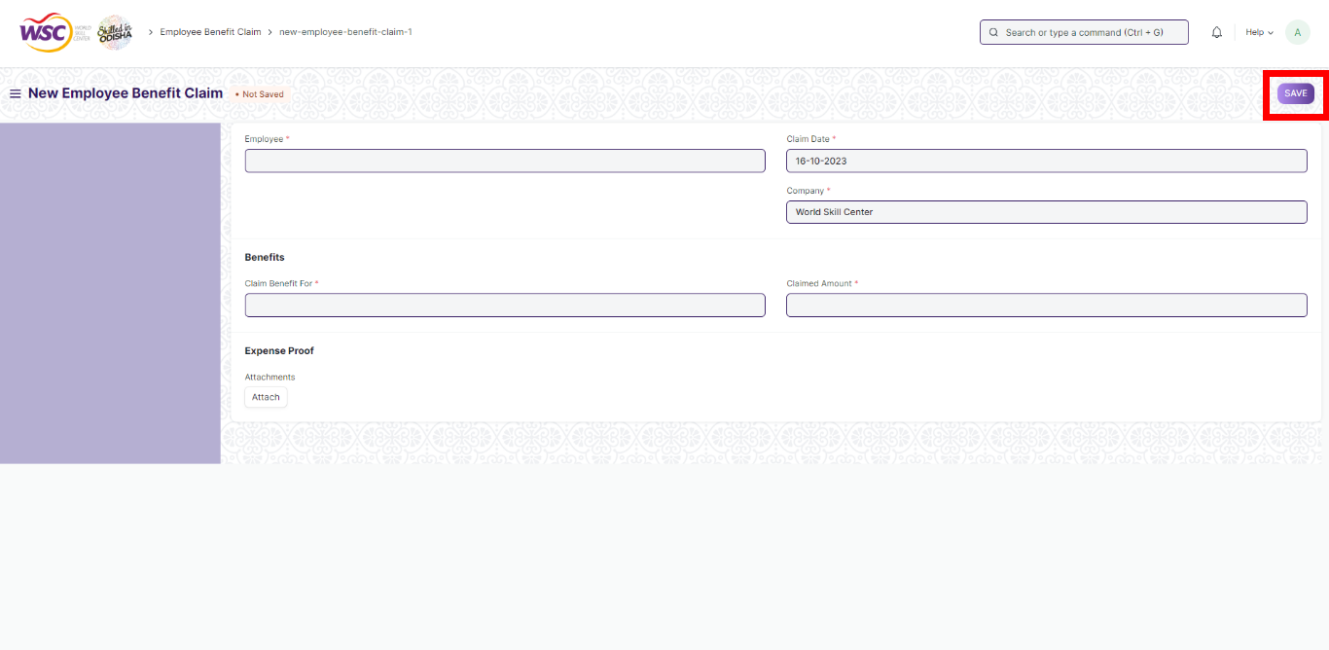

Here, Employee can view the eligible amount as per their Salary Structure Assignment and claim for the amount which they wish to receive as part of their next Salary. Any remaining amount which the employee did not claim for, in a Payroll Period, will be disbursed as part of the last payroll Salary.

**Note :-**

Normal Tax calculation does not include Flexible Benefits as in most cases these are exempted from Tax. To tax these components anytime before the last payroll, use Deduct Tax For Unclaimed Employee Benefits in Payroll Entry / Salary Slip while processing the Salary.

1. **Payroll Setting :-**

****Payroll Settings allow you to configure global settings for the Payroll module.****

**>>> To access Payroll Settings, go to :-**

***Home > Payroll > Settings > Payroll Settings***

## ****1. Working Days & Hours****

#### ****1.1 Calculate Payroll Working Days Based On**:-**

Working Days in Salary Slip can be calculated based on Leave Application or Attendance records.

#### ****1.2 Consider Unmarked Attendance As**:-**

If you set payroll based on Attendance, this option will be shown. It allows you to control the status of unmarked attendance. Eg: If you set it as Present, you don't need to explicitly mark attendance for every employee throughout the month. Just mark the absent days and the rest would be considered as Present by default.

#### **1.3**Include holidays in Total no. of Working Days**:-**

If checked, the total number of working days will include holidays, and this will reduce the value of salary per day. Eg: If there are 10 holidays in a 30-day month, the Total Working Days will be considered as 30 if this checkbox is enabled and 20 if disabled. Then attendance will be checked for these 30/20 days to find out the payment days.

#### **1.4**Consider Marked Attendance on Holidays**:-**

By default, holidays are considered as paid days. If this is enabled and you mark attendance on a holiday, the marked attendance will override holiday status on that day. Eg: if you mark an employee as Absent on a holiday, it will be counted as an absent day and not a paid one.

#### ****1.5 Max working hours against Timesheet**:-**

For salary slips based on the timesheet, you can set the maximum allowed hours against a single timesheet. Set this value to zero to disable this validation.

#### ****1.6 Fraction of Daily Salary for Half Day**:-**

Based on this fraction, the salary for Half Day will be calculated. For example, if the value is set as 0.75, then the three-fourth salary will be given for half-day attendance.

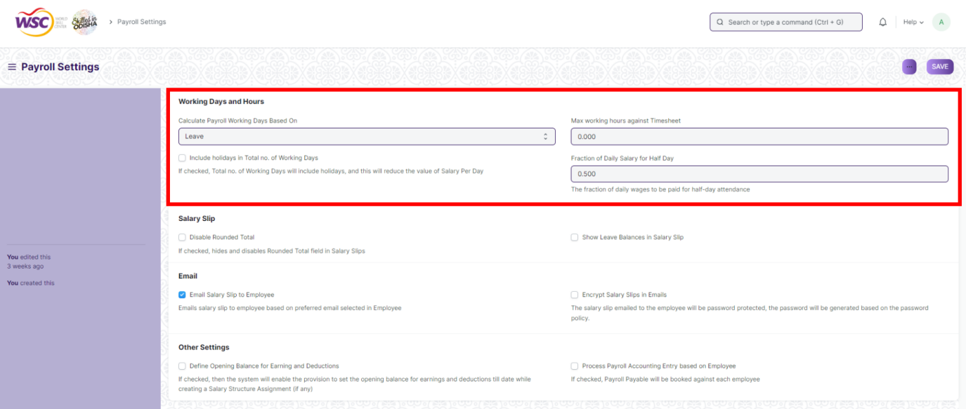

## ****2. Salary Slip**:-**

#### ****2.1 Disable Rounded Total**:-**

If enabled, hides and disables Rounded Total field in Salary Slips

#### ****2.2 Show Leave Balances in Salary Slip :-****

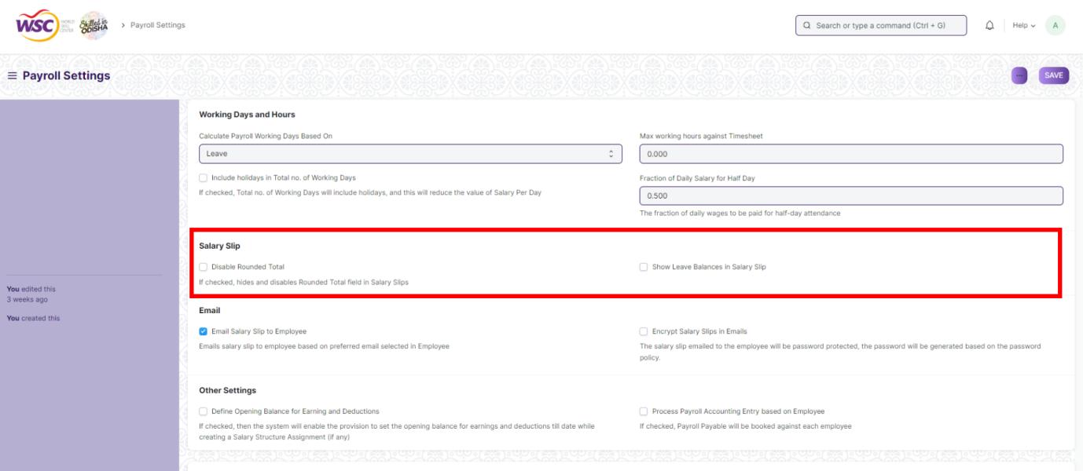

## ****3. Email**:-**

#### ****3.1 Email Salary Slip to Employee**:-**

An email with the salary slip is sent to the respective employee's preferred email address on submission of the salary slip.

#### ****3.2 Encrypt Salary Slips in Emails**:-**

The salary slip PDF sent to the employee is encrypted using the mentioned Password Policy.

#### ****3.3 Password Policy**:-**

This field becomes visible and mandatory on checking the above option for encrypting the salary slip in email.

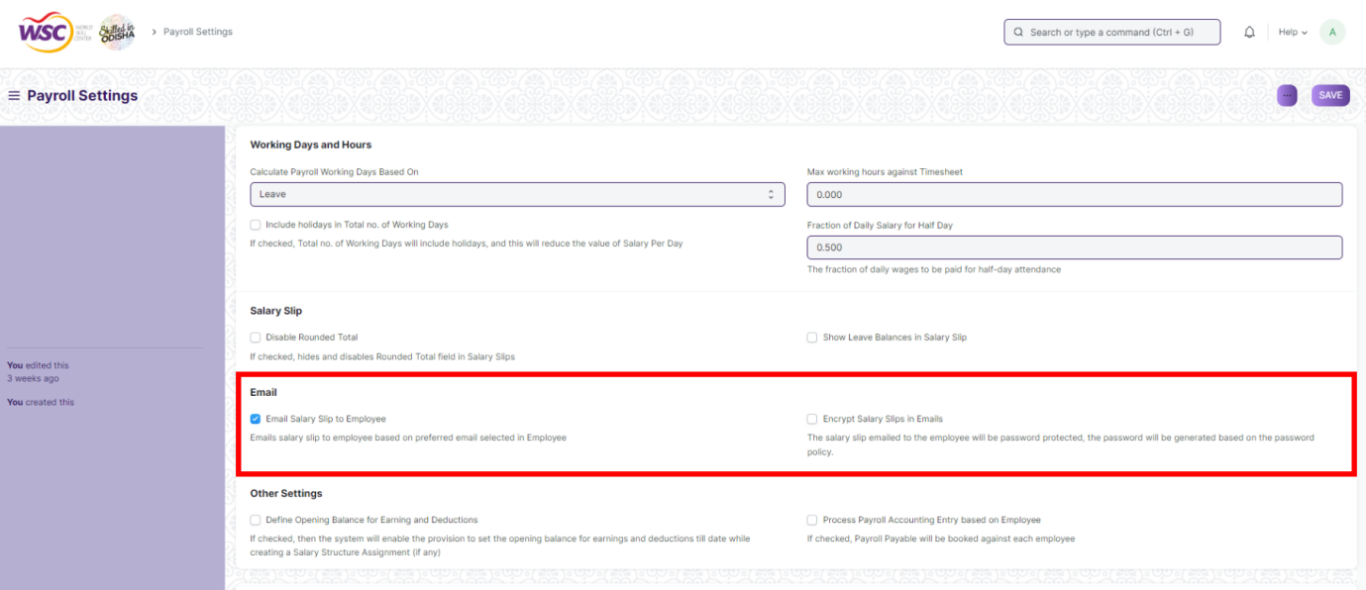

## ****4. Other Settings :-****

#### ****4.1 Define Opening Balance for Earning and Deduction**:-**

If enabled, it will allow you to set up opening entries for ****Taxable Earnings till Date**** and ****Tax Deducted till Date**** in the Salary Structure Assignment if there are no existing salary slips for the employee.

#### ****4.2 Process Payroll Accounting Entry based on Employee**:-**

By default, a consolidated Journal Entry is created against the Payroll Entry for all the employees. If you want a better breakup of payroll amounts per employee, enable this to process employee-wise accounting entries.

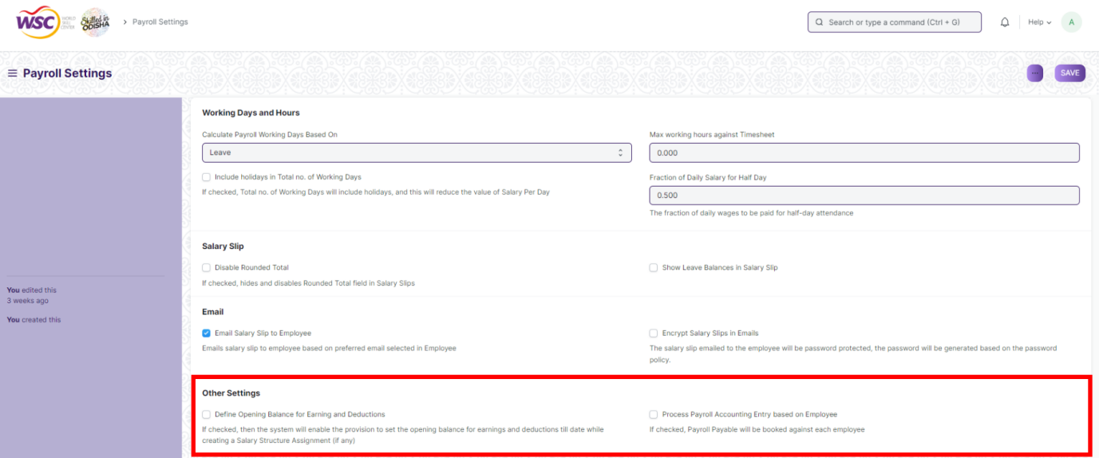

Save & Submit.

